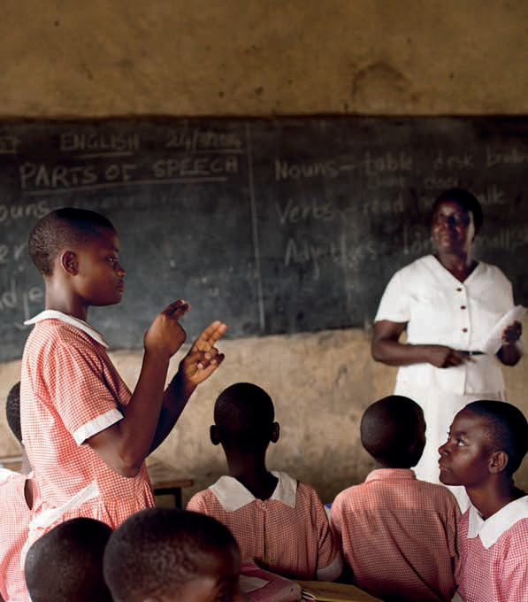
#CostingEquity

1
The case for disability-responsive education financing

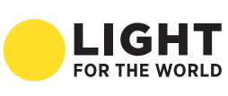

Acknowledgements

This report was written by Juliette Myers with additional writing and research support from Helen Pinnock and Soumya Suresh.

Particular thanks are due to the steering group which guided development of this research and provided written inputs: David Archer (Action Aid), Nafisa Baboo (LIGHT FOR THE WORLD), Benjamin Bach (LIGHT FOR THE WORLD), Louise Banham (Global Partnership for Education), Aletheia Bligh Flower (Leonard Cheshire Disability), Ingrid Lewis (Enabling Education Network), Colin Low CBE – Lord Low of Dalston (Co-Chair All Party Parliamentary Group Global Education, UK), Nidhi Singal (University of Cambridge), Sian Tesni (CBM).

Additional contacts, insights and information were generously supplied by: Rosangela Berman Bieler (UNICEF), Sandrine Bohan-Jacquot (Consultant), Lynn Dudley (GPE consultant), Els Heijnen-Maathuis (Save the Children), Ola Abu Alghaid (Leonard Cheshire Disability), Dr Maria Kett (Leonard Cheshire Disability and Inclusive Development Centre, UCL), Kou Boun Kheang (Save the Children Cambodia), Dr Guy Le Fanu (Sightsavers), Anna MacQuarrie (Inclusion International), Paula Malan (Finnish representative, Ethiopia), Julia McGeown (Handicap International), Polly Meeks (ADD International), Dr Daniel Mont (UCL), Ali Sani Side (National Advisor for Inclusive Education Master Plan, Ethiopia), Richard Orne (Daisy Consortium), Diane Richler (Inclusion International), Marion Steff, (Sightsavers), Anjela Taneja (Global Campaign for Education), Lorraine Wapling (University College London).

The publication of #CostingEquity was made possible with the financial support of the Open Society Foundations. The research was supported by Dr Dragana Sretenov on behalf of the Early Childhood Program. The opinions expressed in this publication are those of the authors, and do not necessarily reflect the policies or views of the Open Society Foundations.

The research has been co-ordinated on behalf of IDDC by LIGHT FOR THE WORLD. Additional financial support for the #CostingEquity research, publication, translation and launch event accessibility has been provided by CBM, Handicap International, Sightsavers and LIGHT FOR THE WORLD. Editing support has been provided by Enabling Education Network (EENET).

Contents

Acknowledgements 2
Executive summary 4

1. Introduction 11
1.1. Sustainable Development Goals 11
1.2. Global context 11
1.3. Defining disability-inclusive education 12
1.4. Inclusive education is cost-effective 11

2. Financing trends 13

3. International donor support 13
3.1. Strategic emphasis 15
3.2. Insufficient and untargeted aid 13
3.3. Information and data 13

4. Domestic financing 14
4.1. Overview 14
4.2. Education budgets exclude children with disabilities 14
4.3. Costing equity in disability inclusive education 16
4.4. Inclusive budgeting 17

5. The future of financing for disability-inclusive education 17
5.1. Increased domestic financing 21
5.2. More efficient use of existing resources and smart investments 19
5.3. External financing 21
5.4. New sources and innovative financing 23
5.5. Better governance, transparency and accountability measures 25

6. Conclusions and recommendations 23
Conclusion 23
Recommendations 25

NOTES 26

International Disability and Development Consortium Inclusive Education Task Group 2016. For more information visit: www.iddcconsortium.net/resources-tools/costing-equity

Executive summary

Context
The Sustainable Development Goals (SDGs) are the first global goals to mention persons with disabilities and provide a clear message to ‘leave no one behind’. SDG4 seeks to ensure ‘inclusive and equitable quality education and promote lifelong learning opportunities for all’. Reaching this goal, as spelt out in the Education 2030 Framework for Action, is a big challenge: half of the world’s 65 million school-age children with disabilities are out of school.

Inclusive education offers quality formal and non-formal learning opportunities for every child within a mainstream system that adapts to the needs of all learners. It necessitates significant changes to legislation, policy, financing, planning and implementation, following a twin-track approach of balancing system-level change with specific support for learners with disabilities.

The cost of exclusion from education is significant – for the individual and country – with countries losing billions of dollars of potential income when persons with disabilities are not educated or working. By contrast, child-friendly, inclusive education (especially when started from early years onwards) brings better social, academic, health and economic outcomes for all learners, and at less cost than special/segregated education.

Global funding for education is declining. Early years provision is particularly underfunded, despite the clear benefits it brings to subsequent education efforts. Governments and donors are not prioritising education investment. Most do not track the allocation of funding by educational levels, let alone disaggregate expenditure linked to SDG targets. The picture is equally concerning regarding humanitarian aid for education, where severe funding deficiencies impact disproportionately on children with disabilities.

International donors
For this report, nine leading bilateral and multilateral education donors were surveyed on their efforts towards disability-inclusive education. The review found emerging commitment to disability-inclusive education across most agencies, with some reporting significantly stronger priority for disability and inclusive education recently.

Commitments do not necessarily reach all levels of the organisation, and none of the respondent donors could show a portfolio-wide approach to inclusive education.

Overall, bilateral and multilateral aid for education is declining, sometimes drastically. Most donor aid does not include amounts earmarked for disability or inclusive approaches. Greater investment in tracking funding for inclusion and reporting against equity indicators is needed to meet SDG commitments. The Global Partnership for Education (GPE) helps stimulate finance and strengthen education systems by encouraging donors to invest in learning, equity and inclusion issues, but it needs to strengthen its own Secretariat capacity and guiding tools in order to better support disability-inclusive education.

Poor data has long been used as an excuse for slow and inadequate action, and this is no longer acceptable. SDG4 commits governments to measure disparities between groups on the basis of disability and other equity markers. Positive steps to improved data include the use of UNICEF’s Multiple Indicator Cluster Surveys (MICS) in collaboration with the Washington Group on Disability Statistics; but greater staff capacity is needed for such tools. Donors are not investing sufficiently in (collaboratively) generating tools, guidance and evidence on disability-inclusive education programming.

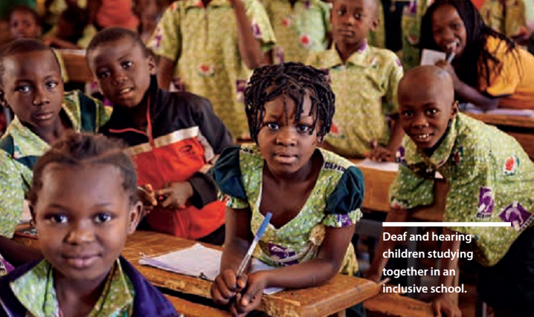
Deaf and hard of hearing children studying together in an inclusive school.

Domestic financing
Domestic resources are the most important source of education financing, and international benchmarks urge governments to allocate 4 – 6 % of GDP to this sector. Households are significant contributors to domestic financing for education, and some countries are striving to expand this further; a move which could exacerbate educational exclusion for persons with disabilities who often come from the poorest households. very few governments commit enough resources to ensure disability-inclusive education, nor disaggregate whether they were funding special or inclusive education; and even having an inclusive education plan, policy or strategy does not guarantee adequate funding for implementation.

Governments need funding formulas which consider the higher costs associated with learners with additional needs, and which take a twin-track approach to removing inclusion barriers. There are various costs to consider. Evidence suggests that designing an accessible learning setting from the start costs less than subsequent alterations. Information and communication technology (ICT) in education can help teachers to adapt lessons and children to access learning, but few in low- income countries have access to ICT. All such costs need to be integral to education financing; but not all costs need extra funds and could be covered through strategic allocation of existing funds, promoting universal design and co-operation agreements among multiple ministries – if personnel were better skilled at disability- responsive budgeting.

The future of financing for disability-inclusive education
Increased domestic financing is vital for achieving disability-inclusive education. In particular, government efforts (supported by donors) to expand tax bases and end tax dodging could drastically change education financing. More strategic use of existing resources, reprioritisation of budgets, stronger focus on quality measures such as improved teacher education, and strong political and community leadership on inclusion are needed, while counter-cyclical and expansionary investment in education may also have a role to play.

The decline in aid needs to be reversed, with total overseas development assistance rising 11 % per year by 2030 (Education Commission, 2016). GPE needs strengthening to play a more pivotal role in promoting the funding of disability- inclusive education. Pooled and blended financing mechanisms and debt relief linked to improved inclusive education spending are options that need to be further investigated, while better harmonisation of aid with national inclusive education plans is vital. Private development assistance is growing faster than overseas development assistance (ODA), and with appropriate guidance could play a catalytic role in disability-inclusive education. Social impact bonds for harnessing private capital for education need further investigation, and the use of earmarked taxes is also a possibility to support systemic changes or individual support interventions.

National Education Accounts, a methodology for compiling information to identify gaps, overlaps and misuse of funds, could help with planning and implementing more inclusive education systems.

Improved budget transparency and accountability could raise education expenditure levels. Civil society organisations (CSOs) and disabled persons’ organisations (DPOs) – if supported to develop the skills – have a key role to play in improving transparency and advocating for greater resource allocation to inclusive education. Faster progress on transparency and accountability could also happen if governments shared disaggregated data on education expenditure, and revenue receipts/ losses.

Summary of recommendations

Financing disability-inclusive education

Evidence & data  - More disaggregation and environmental accessibility data  - Invest in building evidence  - Adopt disability indicators  - Disaggregated funding / spending compliant with UNCRPD | External financing  - Reverse aid decline  - Embed disability- responsiveness  - Harmonise with national plans  - New funding window / facility and strengthen secretariat  - Build evidence around private development assistance, SIBs, earmarked taxes, and National Education Accounts | Accessibility/ reasonable accommodation  - Development minimum standards for accessible teaching/learning materials  - WHO Priority Assistive Products List – basis for planning & budgeting
Philanthropic foundations and private sector
- Engage in global advocacy for disability- inclusive education
- Fund innovative approaches
- Support CSOs to hold government to account
Domestic financing
- Twin-track budgeting
- Meet funding benchmarks
- Increase tax base & end tax dodging
- Improve use of existing resources

Capacity building
- General comment on UNCRPD Art.24 understood
- MoE staff need equitable budget skills
- Build data collection & disaggregation skills
- Budget for raising teacher capacity
- Collaborate to learn
Crisis contexts
- Boost budgets & plan for disability IE
- ‘Education Cannot Wait’ donors must support disability-inclusive education
Accountability
- Full budget transparency
- CSOs/DPOs help monitor & track budgets
- GPE disability reviews: opportunity to strengthen inclusive education plans

1. Introduction

1.1. Sustainable Development Goals
In September 2015, world leaders adopted a new sustainable development agenda promising progressive social, economic and environmental change. The Sustainable Development Goals (SDGs) have a clear message to ‘leave no one behind’ and to mobilise the necessary financial, technical and human resources for this. Persons with disabilities are, for the first time, specifically mentioned in the global goals. Commitments to educating persons with disabilities play a central role. Specifically, SDG4 seeks to ensure ‘inclusive and equitable quality education and promote lifelong learning opportunities for all’. Equality of access to all levels of education for persons with disabilities, and inclusive, accessible learning environments for all are highlighted in the targets, as is the need for access to good quality early childhood development and education (ECDE). The Education 2030 Framework for Action spells out in greater depth the content of SDG 4, including principles, financing and governance dimensions, providing guidance on how to achieve the goal and ultimately inclusive, quality education for all.

1.2. Global context
An estimated 65 million primary and lower secondary school aged children in developing countries have disabilities, half of whom are out of school (Education Commission, 2016).

Many more miss out on ECDE. young children with disabilities are among the most marginalised, often invisible in household and education surveys and excluded from national and global strategies to target out-of-school children (UNICEF, 2013a; Graham, 2014).
Disability is strongly associated with poor primary school completion in Latin America, Asia and Africa (Mitra et al., 2013). Cultural barriers keep children with disabilities out of school, as do systemic and pedagogical barriers (untrained teachers, inaccessible school infrastructure and materials). Girls, young women and persons with particular impairments, including intellectual disabilities, face the most severe educational inequities (LeFanu, 2014; Trani et al., 2011).

1.3. Defining disability-inclusive education
Inclusive education offers quality, relevant formal and non-formal learning opportunities within a mainstream system that adapts to all learners. When children learn together, regardless of differences, everybody in society benefits long term. Good quality inclusive education can remove learning barriers for every child; reduce out-of- school populations; improve transition between education levels; and generally help tackle discrimination.

Inclusive ECDE is critical and can improve children’s presence, participation and achievement in subsequent education levels. Achieving these changes depends on ‘in-depth transformation’ to legislation, policy, planning, administration, financing, and delivery (UNCRPD General Comment Article 24, 2016, para. 9).

The UN Convention on the Rights of Persons with Disabilities (UNCRPD, 2006, Article 24) sets out the right to free, good quality, inclusive education at all levels for children, young people and adults with disabilities ‘without discrimination and on the basis of equal opportunity’. These rights apply equally to those living in crisis contexts. UNCRPD Article 32 recognises the critical role of donors and international co-operation in providing technical and financial resources to this end.

Twin-track approaches lead to more inclusive education systems
A successful disability-inclusive education system takes a twin-track approach: balancing system-level changes (to policy, practice, attitudes) with specific support for learners with disabilities (e.g. providing assistive devices to individuals). However, most government and external financing ignores the existence and importance of these two tracks; too often ring-fencing small allocations for ‘special’ education and failing to invest in system-wide reform.

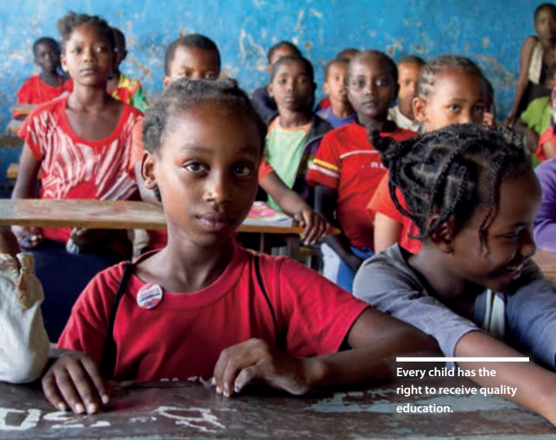
Every child has the right to receive quality education

1.4. Inclusive education is cost-effective
Inclusive education is a human right and an end in itself, but with wider benefits for the economy and society. Evidence from Bangladesh, Cambodia, India, Nepal and the Philippines shows that the returns on investing in education for people with disabilities are two to three times higher than that of persons without disabilities (Lamichhane, 2014).

If good quality education, featuring well-trained teachers and strong peer support, were in place, as many as 80 – 90 % of learners with disabilities could be educated in mainstream schools with only minor additional support (UNICEF, 2012).

Conversely, exclusion impacts on national economic growth, generates significant costs and makes no economic sense (Morgon Banks & Pollack, 2014). Children with disabilities who are not identified early, produce less favourable outcomes and cost more (National Scientific Council on the Developing Child, 2008).

In Burkina Faso, Cote d’Ivoire, Gambia, Lesotho, Liberia, Mali, Nigeria, Senegal and Yemen, the cost of out-of-school children (many of whom will have disabilities) was estimated to be ‘greater than the value of an entire year of GDP growth’ (Thomas & Burnett, 2013). In Bangladesh, lack of schooling and employment for people with disabilities and their caregivers, could be losing the country US$1.2 billion of income annually, or 1.74 % of GDP (World Bank, 2008).

Educational exclusion leads to illiteracy, poor health, severely restricted access to labour markets, low paid employment, malnutrition, unsafe living and working conditions, and disengagement with social services and other protective mechanisms (UNICEF, 2013a; Mont, 2007). The resulting poverty, inequality and insecurity have a grave impact across society.

By contrast, child-friendly, inclusive education can result in better social and academic outcomes for all learners, and contribute to gender empowerment, crime reduction and controlled population growth (Holdsworth, 2002; Macarthur, 2009; Mitchell, 2010; Acedo et al., 2011; Hanushek & Wößmann, 2007).

Despite this, many governments lack the political will to make their education systems disability- inclusive, and believe the returns on investing in schooling for children with disabilities will be low (Sæbones et al., 2015). Where investments are made, the financing of special or segregated education settings – traditionally the only provision for children with disabilities in many countries – continues to be seen as a more tangible and safe option, even though they cost more. In Pakistan, for instance, UNESCO found that special schools were 15 times more expensive per pupil than educating children in mainstream schools (Economist Intelligence Unit, 2014). In South Africa, the average cost of building a new special school in 2012 was $9 million, while upgrading the infrastructure of a mainstream school to accommodate children with disabilities would cost around $366,337 (Human Rights Watch, 2015).

Benefits of early disability-inclusive education
In particular, early childhood interventions, including screening, identification and assessment, help ensure that developmental delays are addressed quickly, future health risks are avoided, and life prospects are significantly increased (UNICEF/University of Wisconsin, 2008; UNICEF, 2012). Investing wisely in early education avoids or reduces the considerable costs of special education, unemployed and institutionalised adults with disabilities, clinical treatments, remedial education and training (National Scientific Council on the Developing Child, 2008). Each additional dollar invested in ECDE brings a return of $6–$17 (Engle et al., 2011).

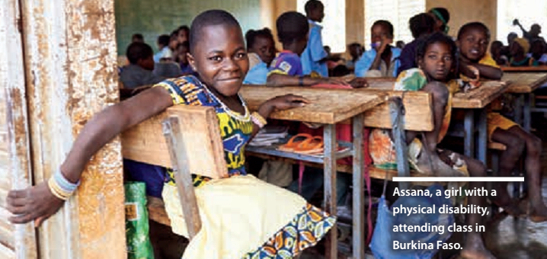
Assana, a girl with a physical disability,
attending class in Burkina Faso

2. Financing trends

In recent years, the education sector globally has been substantially underfunded, and international aid to education is declining (Global Education Monitoring Report (GEMR), 2016). Such trends are of particular concern for children with disabilities, given that they are already often last in line for support. Between 2002 and 2010, aid to education more than doubled in real terms, reaching US$14.2 billion, but has stagnated since (GEMR, May 2016). Total aid to basic education fell in 2013/14, with bilateral donors reducing their aid by 12 % (ibid.). Education is not a priority sector for government or donor investment.

Spending on ECDE and pre-primary education remains particularly low, despite its importance, receiving just 1.15 % ($106 million) of total aid to education in 2014 (Theirworld, 2016). In sub-Saharan Africa, pre-primary education receives just 0.3 % of education spending (Education Commission, 2016). By 2030 the financing gap for achieving pre- primary education in all low- and middle-income countries will be $31.2 billion (Theirworld, 2016). Even the top bilateral donors to primary education (United States, United Kingdom, Norway) do not prioritise pre-primary (ibid.) – which could seriously undermine any positive outcomes from their basic education investments. Getting a true picture of funding to each level of education is not easy, however. Only 46 % of countries split their education spending so that they can identify allocations by level (Development Finance International, 2015b). The further disaggregation needed to track expenditure linked to SDG targets is often non-existent.

Severe deficiencies and inflexibility in humanitarian aid for education also impact disproportionately on children with disabilities. These children often have no access to educational opportunities or protection programmes in crisis contexts, despite being more vulnerable. Humanitarian response plans, appeal mechanisms and needs assessments do not make provision for children with disabilities.

3. International donor support

As part of the #CostingEquity research, representatives of nine leading bilateral and multilateral education donors were surveyed on their agencies’ efforts towards disability-inclusive education: DFAT (Australia), DFID (UK), European Union, GIZ (Germany), Global Partnership for Education, Norad (Norway), UNICEF, USAID (USA), and World Bank. Strategies, monitoring frameworks and annual reports were reviewed for a wider range of large basic education donors, donors supportive of inclusive education and disability, and donors who have submitted reports against the UNCRPD’s Article 32 on international cooperation.

3.1. Strategic emphasis
The review found signs of emerging commitment to disability-inclusive education across most key donor agencies. Several of the largest agencies reported significantly stronger priority for disability and inclusive education in the last one to two years.

DFID has made significant changes towards promoting disability-inclusive education in organisational strategies, monitoring frameworks, and staff awareness, as has UNICEF. DFAT has articulated its commitment to disability-inclusive education much more clearly in strategies and reporting since 2014. However, at all three agencies, strategic frameworks and principles for action were not guaranteed to be in place across all country teams, and few staff could be identified as fully engaged in promoting disability-inclusive education.

Despite thematic priorities on disability and inclusion, and some strong country-level partnerships, USAID and the EU have some way to go in demonstrating a strategic focus on disability-inclusive education in their partnerships and delivery.

Several donors reportedly encourage aspects of inclusive education delivery and financing in country plans and programmes, but none could show a portfolio-wide approach. Donors therefore still have a lot to do, to fully promote structural elements of disability-inclusive education at country level. GPE reported developing tools to help countries manage and monitor equity and inclusion issues, but progress has slowed since 2014, with capacity at the GPE Secretariat limited. GPE plays a critical role in stimulating finance and strengthening education systems in developing countries by encouraging donors to invest in learning, equity and inclusion issues. It could potentially provide the guidance that States need to produce disability-inclusive education responsive Education Sector Plans and budgeting, if the Secretariat’s capacity and guiding tools are strengthened.

3.2. Insufficient and untargeted aid
The 2008 global financial crisis led to falling aid receipts from bilateral donors, and a shift away from basic education. France, Japan, the Netherlands and Spain each reduced aid to basic education by at least 40 % (GEMR May 2016). Most large donors allocate funds to basic education programmes in developing countries (including pre-primary education) without earmarking specific amounts for disability or inclusive approaches. Norad (2016) was unusual in being able to show that 29 % of its education funds were directed to inclusive education.

Elsewhere, the lack of data on allocations suggests that disability and inclusive education are not yet a priority for the leadership of large donor agencies.

3.3. Information and data
Poor data has long been used as an excuse for slow and inadequate action. Currently, the data on children in conflict and protracted crises is not particularly rigorous, but no one would advocate withholding action until reliable data is available. The same should apply to disability. SDG4 commits governments to measure disparities between groups on the basis of disability and other equity markers, so greater investment in disaggregated data and tools for inclusive education planning is expected.

Positive change is promised by UNICEF’s Multiple Indicator Cluster Surveys (MICS), which track how disabilities are affecting children in household surveys, in collaboration with the Washington Group on Disability Statistics; and the UNICEF Guide for Including Disability in Education Management Information Systems (UNICEF, 2016). DFID is also advocating for the SDG framework to use disability indicators more aggressively (DFID, 2015). However, the success of these initiatives hinges on investments in staff capacities.
High level support within donor agencies is not yet in place to generate tools, guidance and evidence on the scale needed to make education sector plans and programmes disability-inclusive. Overcoming knowledge and capacity gaps, through jointly developing tools and evidence, is a shared responsibility across donor agencies. Unfortunately, the current slow pace at which evidence is being generated or documented by small teams across donor agencies, risks delaying action for disability inclusive education. Scaling up such efforts would offer clearer solutions for large- scale donor investment, encouraging expansion in the funds targeted at disability-inclusive education.

4. Domestic financing

4.1. Overview
Domestic resources will continue to be the most important source of education financing. The Incheon Declaration urged countries to comply with benchmarks for domestic funding of education (4 %– 6 % of GDP and/or at least 15 – 20 % of public expenditure). Provision for reasonable accommodation measures (such as adapted infrastructure and teaching and learning materials), to reduce inequities for learners with disabilities, pushes states to achieve the upper limits of these benchmarks (Education 2030, 2015; para. 105; Education Commission, 2016).

Households are significant contributors to the domestic financing of education. In low- income countries, household contributions to education can amount to almost half of domestic expenditure (Brookings, 2015a) and can represent a higher contribution to education spending than governments make (GEMR, July 2015).

Since household poverty and disability are often inherently linked, it is therefore not surprising that children with disabilities face greater risk of exclusion from education.

In Ethiopia, where 96 % of children with disabilities are out of school, the Education Sector Plan anticipates closing the financing gap using household and community contributions (Government of Ethiopia, Federal Ministry of Education, 2015b). Increasing reliance on household support for education financing risks exacerbating educational exclusion for persons with disabilities.

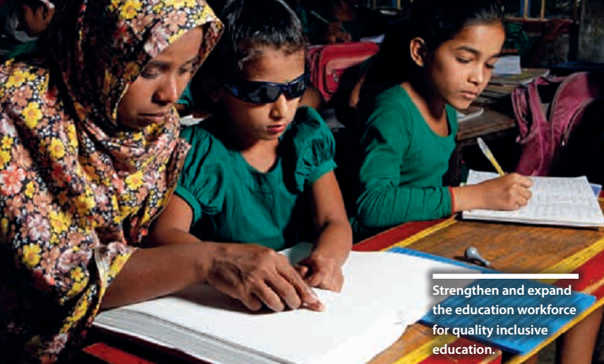
Strengthen and expand the education workforce for quality inclusive education.

4.2. Education budgets exclude children with disabilities
Very few governments commit enough resources to ensure disability-inclusive education. A recent review for GEMR 2 016 found that only 31 low- and middle-income countries1 (out of 76) have specific budget allocations for children with disabilities or for special education (Development Finance International, 2016); and even these budget lines do not clearly indicate whether the finances are for special or inclusive education.

The inclusion of disability or special needs education in a country’s education sector plan is a good predictor of budgetary allocations. Unfortunately, the presence of an inclusive education plan, policy or strategy, is not a guarantee of adequate funding. South Africa’s White Paper 6 on Inclusive Education was a highly praised plan for developing an inclusive education system, but its lack of implementation progress has been blamed on slow and inadequate financing (Wildeman & Nomdo, 2007; Human Rights Watch, 2015).

Where governments fail to make budgetary provision for inclusive education, children with disabilities continue to be marginalised. For example, in Peru only 0.05 % of the total Ministry of Education budget was allocated to special schools, and the 2010 National Budget had no figures for inclusive education activities. Perhaps inevitably, therefore, 87.1 % of Peru’s children and adolescents with disabilities are excluded from education. Civil society groups highlight that this lack of investment is illustrative of the exclusion of persons with disabilities from the education system (CONFENADIP, 2011).

4.3. Costing equity in disability inclusive education
To achieve disability-inclusive education there must be substantial additional investment in systemic reforms, through a twin-track approach. various financing models for supporting disability- inclusive education already exist across developing countries, such as cash transfers, well-targeted school improvement grants, and reasonable accommodation funds. However, all governments must urgently develop their own funding formulas which take into consideration the higher costs associated with some learners with additional needs (Education Commission, 2016).

Children with a range of disabilities (and all children) benefit from a safer and more user- friendly environment. Classrooms, playgrounds, water and sanitation facilities, for instance, all need to be made accessible. Negligible extra costs (a 1 % increase) are involved if accessibility is built in at the design phase, while retrofitting schools could be 20 % more expensive (Steinfeld, 2005).

Adapted learning materials such as Braille books, sign-language and captioning, audio books, large print books and easy-read books, are often extremely scarce in low-income countries. For example, less than 1 % of materials are thought to be available in accessible formats for blind or visually impaired readers (World Blind Union, 2013), yet as much as a 20 % increase in student achievement is possible if students have their own textbooks (Education Commission, 2016).

The Marrakesh VIP Treaty on copyright, which entered into force on 30 September 2016, is set to necessitate the creation of accessible versions of books for blind, visually impaired and otherwise print disabled readers.

Information and communication technology (ICT) in education can be a game changer: helping teachers adapt lessons and presentation of content and exercises; helping students with visual impairments to use accessible formats that boost their participation; and giving a ‘voice’ to those with communication disabilities by using voice output technology or symbol-based software. In most low-income countries only 5 – 15 % of those who need assistive technology have access. High costs are a key barrier, as is lack of awareness about the existing accessibility functions built into everyday technologies such as laptops and tablets (UNICEF, 2013b). The Education Finance Commission recommends a cross-sector investment to get every school online and put in place the broader digital infrastructure necessary for learning (Education Commission, 2016). A similar investment is required to ensure that teachers, policy-makers, and other key stakeholders are informed and skilled to make optimal use of technology for accessible learning and teaching.

Assistive devices remain too expensive for many families of children with disabilities, despite some countries offering tax breaks on their purchase. One study in Kenya found high prices for imported devices, and low market demand was driving up costs (GCE UK / APPG EFA, 2015). The range of costs in relation to assistive devices, include: research and development; procurement, maintenance and distribution; specialist personnel; teacher education; and policy development or implementation (UNESCO/G3ict, 2014).

4.4. Inclusive budgeting
National budgets play a key role in ensuring educational opportunity is equalised between groups of children. Just as gender-responsive budgeting has been crucial in understanding the impacts of budgets on girls and boys (Unterhalter, 2007), disability- inclusive budgeting at national and decentralised levels is needed to mitigate the disadvantages faced by learners with different disabilities and ensure quality education (GCE Global, 2014; GEMR, July 2015).

Inclusive budgets target the most marginalised groups, ensuring that funds are available to support specific reforms and that these funds are spent equitably and effectively for greatest impact. Assigning nominal budgets to ‘special education’, and expecting this to adequately support the education of children with disabilities, is simply not good enough. Government education budgets should be aiming to improve and maintain the whole education system with inclusion in mind, and provide for individual accommodation measures where needed. This is rarely the case in low-income countries. For instance, a recent study in Papua New Guinea found that government funding for learners with disabilities was only available to those studying in NGO-managed Special Education Resource Centres, a major disincentive to including children with disabilities in regular government-run schools (Kett et al., 2016).

Technical teams within ministries of education need to be sufficiently skilled to budget appropriately for equity. The Joint Education Sector review in Cambodia, 2015, found that lack of co-ordination resulted in a failure to budget appropriately, and left equity budgets underspent (Joint Government – Development Partners, April 2015). In decentralised education systems, understanding of and commitment to inclusive education can vary between provinces, affecting budget allocations and spending. Five out of nine provinces in South Africa, for instance, did not allocate any resources to expanding inclusive education in 2014; while four had never allocated any budget to inclusion, ‘resulting in serious backlogs of the implementation’ of the inclusive education policy (Human Rights Watch, 2015).

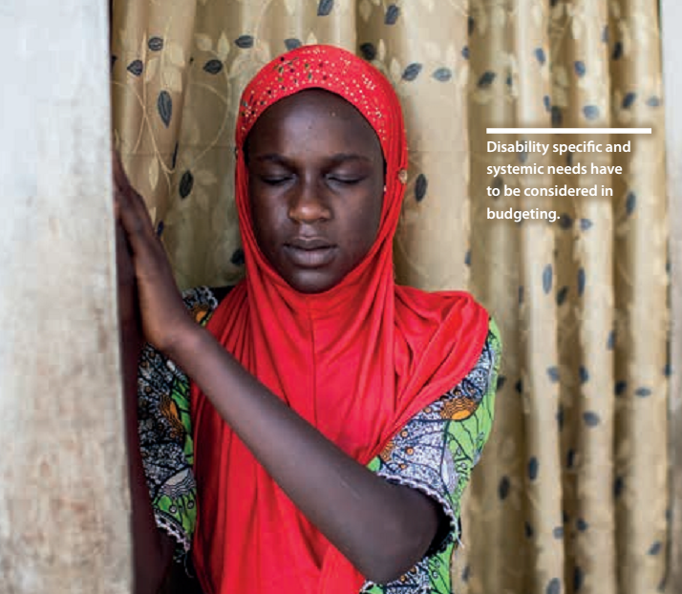
Disability specific and systemic needs
have to be considered in budgeting.

5. The future of financing for disability-inclusive education

Sustained, innovative and well-directed additional financing for education will be needed to reach the SDG4 goals and targets; and existing resources need to be targeted more strategically, with a focus on supporting marginalised groups, cutting waste and corruption, and enhancing transparency and accountability. Equitable allocation of resources is an innovation that all countries need to work on.

Sustainable financing for education needs to come from domestic resources, bolstered by economic growth, progressive taxation, good governance and transparent institutions. Long-term investments in education are crucial and can lead to long-term returns; while short- term aid commitments and/or sudden surges in spending, have limited effectiveness – reaffirmed by the Addis Ababa Action Agenda.

5.1. Increased domestic financing
Increased domestic financing offers the most significant and sustainable way for governments to achieve disability-inclusive education. The Commission on the Financing of Global Education Opportunities (Education Commission, 2016) highlights the need for governments to develop financing formulas and harness technologies that give greater support to children most in need, such as those with disabilities. It estimates that governments in low- and middle- income countries must increase domestic resources for education from around $1 trillion in 2015 to $2.7 trillion by 2030, using a range of measures, including raising more taxes, maintaining growth, and increasing education’s share of overall public expenditure.

Progressive taxation is the largest source of revenue for governments (Action Aid, 2009).2 Expanded tax bases in developing countries, alongside action to address aggressive tax avoidance and damaging incentives, could lead to a dramatic breakthrough in education financing. Donors can support this by building capacity and strengthening tax systems, as well as revising tax treaties that are harmful to developing countries (Action Aid 2015). The Copenhagen Consensus estimates that every $1 spent on modernising and reforming tax, yields $45 in returns (Brookings, 2015a).

The impact of unfair tax systems on a country’s potential to achieve inclusive education targets cannot be under-estimated. In Nicaragua, tax exemptions are worth two-and-a-half times the education budget. In Zambia, more than twice the total education budget is lost through corporate tax dodging. In Tanzania, the revenue lost to tax dodging could cover the cost of training all untrained primary school teachers and 70,000 new teachers; building 97,000 accessible new classrooms; and furnishing every child with a reading and maths textbook (GCE Global, 2013).

Many countries struggling to meet education targets fail to leverage their tax base sufficiently. If just one-fifth of modest increases in tax raising efforts in 34 sub-Saharan African countries were channelled to education, $4.5 billion would be raised for the sector (EFA GMR, 2013 – 14). One study estimated that ‘developing countries lose US$139 billion a year just from corporate income tax exemptions. In just over two months, if channelled to where it is most needed, this could fill the annual global finance gap for basic education’ (Action Aid, 2016). Among developing countries, Ethiopia has one of the lowest tax/ GDP ratios (12 %), largely due to generous tax exemptions (amounting to approximately 4.2 % of GDP in 2008 – 09). If Ethiopia scrapped these exemptions and allocated 10 % of the new revenue to basic education, then 1.4 million of the 1.7 million out-of-school children (many of whom are children with disabilities) could access schooling and the ambitious inclusive education plans in the Education Sector Development Plan v could be achieved (EFA GMR 2013 – 14).

Losses also occur when governments sell natural resource concessions for less than their true value. In Peru, estimated losses from failure to collect mining royalties adequately from 1994 to 2006 could have paid for all of the half-a-million out-of- school children to attend four years of school (GCE Global, 2016).

Efforts to strengthen progressive tax systems and address tax dodging have the potential to raise huge sums: US$139 billion a year from persuading ministries of finance and revenue authorities to end harmful tax incentives; and US$100 – 200 billion a year from effective action to end aggressive tax avoidance in developing counties (Action Aid, forthcoming 2016). If the benchmarked 6 % of these funds were used for education, breakthrough results could be realised for disability-inclusive education.

5.2. More efficient use of existing resources and smart investments
Good quality inclusive education is the result not just of sufficient financing, but strategic use of existing resources, inclusive legislation, policies and systemic reform programmes, effective partnerships, strong leadership, and priorities that lead to results. Quality is also driven by effective management of supply-side factors such as teacher education, education workforce expansion (teacher aids, social workers, therapists, CBR workers) and quality, curriculum, textbooks, and parental support (Commonwealth Education Hub, 2015). Inclusive, equitable, disability-responsive budgeting of existing resources is needed, to open up educational opportunities for all, and phased approaches may be more effective than efforts to reform all levels of education at once (Malala Fund, 2015). Counter-cyclical and expansionary investment in education may have a role to play here, ensuring that education budgets are not compromised by austerity and that ministries of finance can factor in long-term returns into medium- to long-term expenditure forecasts (GCE Global, 2016).

Short-term reprioritisation of budgets can enable governments to pursue inclusive education without significant additional costs. For instance, already planned and budgeted revisions to teacher education could be brought forward and directed towards strengthening content around inclusive pedagogies and approaches – with no additional cost implication. When budgets are tight, a well remunerated, effective, qualified teacher, working in a school environment with ongoing pro-inclusion support from leaders and community, can have more impact on quality and equity than any other (potentially high cost) intervention. Strong leadership on disability inclusion, publicly demonstrating political will, can also play a significant role in tackling stigma and removing attitudinal barriers to inclusion – and strong leadership and political will does not require a budget.

According to the International Commission on Financing Global Education Opportunity (2016) the combined effects of improved teaching methods, provision of learning material, and remedial help for those who fall behind, can potentially improve learning outcomes by 25 – 53 %. The smart investments identified for improving quality education and learning outcomes, are the same investments that would boost disability- inclusiveness in education.

5.3. External financing
The decline in aid needs to be reversed, and the majority share of resources needs to be channelled to those countries with greatest need, and those in emergency situations.

The total overseas development assistance (ODA) for education needs to rise by an average 11 % per year (from $16bn to $89bn) by 2030 (Education Commission, 2016). The Commission asks donors to considerably upscale education investments; increasing the levels of GDP allocated to overseas development assistance (raising the allocation to education from 10 % to 15 %) and ensuring that provision for education accounts for 4 – 6 % of humanitarian assistance. This needs to be combined with generally improving aid effectiveness (Education 2030, 2015).

The Addis Ababa Action Agenda (2015) provides a global framework for financing the SDGs. It recognises the importance of providing quality education for children with disabilities in ‘inclusive and effective learning environments for all’ (ibid, para.78), and commits to upscale investments and international cooperation, to strengthen the Global Partnership for Education (GPE), increase qualified teacher numbers and upgrade inclusive educational facilities. It also reminds us that international financing can improve tax collection and build public services and enabling environments (para.54).

Pooled and blended financing mechanisms might help unlock additional resources, but more research on the impact of public-private partnerships for disability-inclusion is needed. In those countries which spend a significant amount of their budgets on debt repayments, debt relief could be linked to enhanced spending in education and other social sectors (GCE Global, 2016). Better harmonisation and coordination is needed to improve aid effectiveness, which must include alignment of funds and technical assistance with national plans that specifically prioritise disability- inclusive education and take a twin-track approach.

5.4. New sources and innovative financing
The role of non-state actors in education remains contentious. Nevertheless, innovative sources of financing and new partnerships are needed to meet the ambitious SDG agenda. In 2012, private development assistance (PDA) from OECD countries, including charitable, religious and private sector grants, totalled $30 billion, equivalent to approximately 25 % of total net ODA. PDA has been growing faster than ODA, with a 51 % increase between 2006 and 2011 (Brookings, 2015a), although education has not been a priority sector. There may be more interest in education from foundations and other donors in emerging economies. One study of Arab donors, for instance ‘found that cultural and religious traditions– Islamic guidelines strongly encourage giving to education–provide a strong foundation for greater engagement in the future’ (Brookings, 2015a).

With appropriate guidance on approaches to investment in inclusive education and respect for human rights, charitable foundations and the private sector could play a catalytic role in disability-inclusive education, targeting funding to the most marginalised and leveraging resources and expertise in key areas.

Social impact bonds
Social impact bonds (SIBs) potentially harness private capital for public services like education. Like results-based financing (RBF), payment of service providers working within SIBs is contingent on success. However, SIBs differ from RBF in that investors invest upfront into a bond holding fund. This is returned to investors, plus interest, if a service provider achieves key outcomes. When these outcomes are achieved, outcome funders such as donors and government must repay the cost of the initiative. If the investment does not yield a positive outcome, the investors must shoulder the cost. This model can incentivise outcome funders to invest in social development, because they only pay for services that yield impact.

SIBs may have a role to play in bridging financing gaps where domestic resources fall short, and where interventions have been shown to be cost-beneficial due to the long-term social investment they provide. SIBs could focus on delivering capacity building of teachers, health professionals, ECDE practitioners, community- based rehabilitation workers and so on, rather than infrastructure which has traditionally been the focus of public-private partnerships (Brookings, 2015b).

However, evidence on the effectiveness of SIBs is still emerging, primarily from developed country contexts. Further, because SIBs are contingent on investors being able to base their investment decisions on evidence of proven approaches, there would need to be significant improvement in the quantity, rigour and documenting/sharing of research on disability-inclusive education approaches and impacts, in order for such initiatives to attract SIB investment.

Earmarked taxes
Earmarked taxes assign revenue from specific taxes to a sector, such as education, providing the only source of financing for a particular programme or blending with other sources. It may also be enshrined in law or policy (Action Aid, 2016). The Ghana Education Trust Fund is funded by 2.5 % of VAT collections, while Nigeria’s Tertiary Education Trust Fund is financed by 2 % of assessable profits from companies (Action Aid, 2016). So long as any new tax is providing additional revenue to existing allocations, earmarked taxes could provide a time- limited boost to financing the systemic change or individual support track of inclusive education.

5.5. Better governance, transparency and accountability measures
Improved transparency and accountability may yield unexpected positive outcomes. Better budget accountability can raise expenditure levels. Countries which improved budget transparency during the last decade of the Millennium Development Goals increased related spending faster, and made more progress, than those which did not (Development Finance International, 2015b).

Civil society organisations (CSOs) have played a key role in improving accountability and transparency in education budget processes – such as COSYDEP’s participatory Budget Watch in Senegal (GCE Global, 2014) and NEP Cambodia which is part of the National Education Sector Working Group (see the full #CostingEquity report for details). CSOs could now build on this to advocate for greater resource allocation to inclusive education. Monitoring and tracking of education can significantly increase funds received at school levels (Education Framework for Action 2030, paragraph 108), but there must be commitment to mutual accountability, transparency, and targeting of resources to the most vulnerable, including children with disabilities, and least developed countries. DPOs and organisations working in disability-inclusive education must be fully engaged and represented at the heart of these processes. They must also be adequately skilled, moving away from the tokenistic engagement that characterises some country level Local Education Groups.

SDG4 commits governments to measure disparities between groups on the basis of disability and other equity markers, so greater investment in disaggregated data and tools for inclusive education planning is expected. Faster progress on transparency and accountability, at little extra cost, could happen if governments publicly shared documents and data in which they disaggregate spending by gender, region and beneficiary group. This is particularly critical for tracking equitable resource allocations for learners with disabilities.

Annual, detailed publication of revenue receipts (by type of tax, sector, size of enterprise), revenue losses (due to exemptions and incentives), and analysis of tax and spending policies to see if they combat inequality, would be helpful. External donors also need to improve and publish their aid data, disaggregated by sector, subsector, gender, disability and other equity indicators.

A new project to develop National Education Accounts in eight countries may help us better understand how education is financed (by public, private and external donor assistance). A globally comparable methodology is being developed that enables the compilation of information that will identify gaps, overlaps and misuse of funds. If successful, National Education Accounts offer potential for planning and implementing stronger, more inclusive education systems.

The current lack of data on spending may not be due to lack of political will, but to lack of technical capacity and lack of demand from parliamentarians and civil society. Raising awareness and strengthening technical knowledge, among DPOs in particular, as well as improving advocacy to stimulate demand for better data, is therefore key for improving accountability around equitable education financing.

6. Conclusions and recommendations

Conclusion
Despite growing interest and effort, there is a lack of technical and financial resources to deliver on the SDG inclusive quality education targets. More equitable, inclusive approaches to resource allocation and budgeting are required. This includes innovative and flexible earmarked funds to support learners with disabilities in mainstream pre-school, primary and secondary schools, and learners with complex disabilities who require alternative pathways into education. Disability-inclusive education will only work if well supported by strong cross-sectoral equity and disability co- ordination at central, district and local levels.

Multiple stakeholders have important roles to play. Governments in low-income contexts need to close persistent gaps between inclusive education policy and practice, and provide adequate domestic financing for this; but they cannot do it alone. The extent of systemic reform needed to improve equity requires resources, expertise and policy interventions from diverse stakeholders.

Domestic efforts, international co-operation and public-private partnerships should all ensure that costs associated with inclusion of learners with disabilities, including the most marginalised, are represented in education budgets. NGOs/DPOs/ CSOs need funding and opportunities to offer technical expertise to ministries, and they need resources for advocacy and inclusive budget tracking. Better co-ordination is needed at national and global levels, along with stronger co-operation on implementation, monitoring and accountability

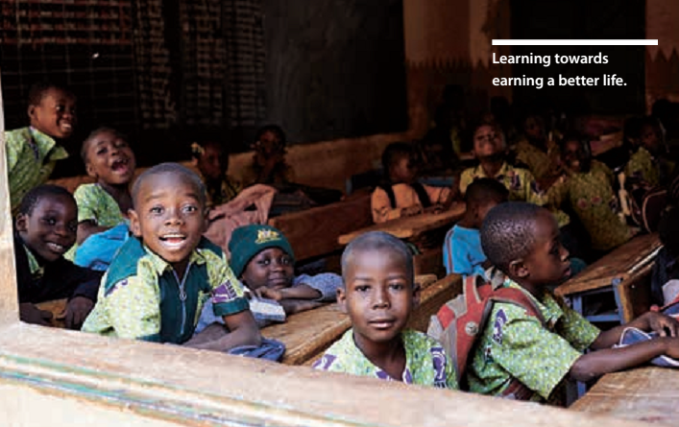

Recommendations
Specifically, we call on all actors to take forward the following recommendations:

Evidence and data
- Accurate data on children with disabilities, disaggregated by gender, age and type of disability, as well as school level data on accessibility and teacher training, etc., is needed to ensure adequate resourcing at all levels of education.
- All stakeholders should work collaboratively, using the Washington Group / UNICEF Child Module, to strengthen national surveys, censuses and Education Management Information System (EMIS) data to ensure disability-disaggregation and collection of information on environmental barriers to education.
- Strengthen and invest in developing an evidence base of effective approaches that improve learning outcomes for students with disabilities and quality, disability responsive inclusive education systems via rigorous evaluations. These would contribute towards spelling out new common standards and targets for inclusive education based on the UNCRPD General Comment on Article 24.
- Donors and governments should be held accountable to regularly produce and review data on education funding, disaggregated by levels of education, disability and other equity markers, including whether spending is compliant with the UNCRPD.
- Donors should adopt disability programme indicators including gender, location and age disaggregation, as well environmental indicators related to accessibility.
- The World Bank’s Systems Approach to Better Education Results and DFID’s Research on Improving Systems of Education (RISE) need to deliberately collect and analyse data towards determining a country’s level of disability-inclusiveness in education.

Domestic financing
- Governments should finance a twin-track approach to inclusive education (systemic change alongside specific initiatives to support the needs of learners with disabilities), and all donors must support them in this.
- Governments should prioritise meeting internationally agreed benchmarks for funding education at 4 – 6 % of GDP and/or 15 – 20 % of public expenditure. However, least developed countries need to reach or exceed the upper benchmark limits in order to address disability accessibility and the confounding circumstances that increase inequities and disadvantages.
- Governments should increase the domestic resource base through progressive taxation, counter-cyclical investment, and addressing tax dodging.
- Governments should adopt disability-responsive budgeting and use this to make more strategic use of existing resources, as well as to develop funding formulae that take account of higher costs associated with including learners with additional needs.

External financing
- All donors should prioritise efforts to reverse the decline in aid for education.
- Donors should normalise disability- responsiveness as a core criterion in education funding, both with partner governments (as UNICEF has done), and with implementing contractors (consultants, NGOs, etc.). This should be reflected in donor policies and strategies on disability and inclusion, that all existing and new staff must be oriented on.
- Donors should ensure that funding for education is harmonised with national inclusive-education oriented plans.
- Donors should review all tax and trade policies to assess their impact on developing countries, making revisions where there is a risk of harm, and supporting an international tax body with universal membership.
- GPE should develop a new financing window or initiative for disability-inclusive education, with an explicit twin-track focus, to catalyse additional financing and ensure that donor financing is better targeted within core support to Education Sector Plans. This window within GPE could help to bring private sector, charitable foundations and other new donors on board, generating new partnerships and prioritising flexible ways of targeting resources. Innovation grants as well as large-scale evidence generation should be prioritised. INGOs DPOs could be a driving force within the initiative, with full oversight and participation in the window’s design, implementation and management. The GPE Secretariat needs strengthening for this to happen, however.
- Investment is needed in building evidence around alternative financing related to private development assistance, Social Impact Bonds (SIBs), earmarked taxes, and National Education Accounts, in relation to disability-inclusive education.

Accountability
- Full budget transparency and accountability mechanisms must be in place, and linked with improved data collection and sharing. CSOs/DPOs and parents’ associations should be facilitated to engage in all relevant budget procedures, monitoring and tracking.
- Forthcoming GPE reviews of disability-focused work should be used to facilitate revision of country and partner plans, to strengthen disability focus in education where needed. A taskforce incorporating civil society (IDDC, UNICEF and Global Campaign for Education) should support the review.

Capacity-building
- Technical teams within ministries of education need to be sufficiently skilled to set, manage/disburse and monitor budgets for equity.
- Within donors, government and NGOs/CSOs/ DPOs there needs to be more awareness of and skills for appropriate data collection and disaggregation.
- Essential budget requirements include provision for improving the capacity of the teaching force through reform of pre- and in-service teacher education, ongoing support, and professional development, as well as expanding the education workforce via teacher-aids, therapists, social workers, etc.
- Collaboration is essential for learning more about disability-inclusive education, so all stakeholders need to actively engage in partnerships to bridge information, capacity and resource gaps.

Accessibility/reasonable accommodation
Various opportunities exist for donors and governments to better define needs and thus plan/ budget more appropriately, including:
- Donors and governments need to agree minimum standards for visual, language and physical accessibility of teaching and learning materials, which could be similar to the international Web Content Accessibility Guideline 2.0.
- The new global WHO Priority Assistive Products List includes 12 different technological solutions that would help children with disabilities to access education, and offers a starting point for planning and budgeting.

Emergencies
- Humanitarian budgets, response plans, appeal mechanisms and needs assessments should be boosted and make provision for disability- inclusive education.
- The new ‘Education Cannot Wait’ fund, launched at the World Humanitarian Summit in May 2016, has attracted initial investment of $42 million for Yemen, Chad and Syria. The major contributors (United States, United Kingdom, Norway, and the European Union), must continue their track record of supporting disability inclusive education within this fund.

Philanthropic foundations and private sector
- These entities need to engage in global advocacy efforts, including research, influencing key multilateral and bilateral stakeholders and governments.
- They should fund and engage with innovative approaches to inclusive education that align with national sector plans and have the specific goal of being scaled up.

NOTES
1. These countries are: Angola, Bangladesh, Benin, Bhutan, Bolivia, Cape Verde, Colombia, El Salvador, Fiji, Ghana, Honduras, India, Kosovo, Liberia, Malawi, Mozambique, Nepal, Nicaragua, Pakistan, Peru, Rwanda, São Tomé and Príncipe, Sri Lanka, Solomon Islands, Tanzania, Timor Leste, Uganda, Zambia and Zimbabwe (Development Finance International, 2016).
2. In sub-Saharan Africa, Asia and Latin America, tax revenue accounts for nearly 80 % of total revenue. Non- tax revenue includes aid, income from natural resource extraction, and administrative fees and charges (Action Aid, 2009).
3. Systems Approach for Better Education Results (SABER), allows for the identification of the best proven practices that ensure system wide reforms. SABER rates the quality of different systems and policies of countries by using a range of data collection methods (e.g. policy analysis and expert opinion) to consider progress in aspects such as education workforce, leadership, financial resource, equity and inclusion.

International Disability and Development Consortium (IDDC) is a global consortium of disability and development NGOs, mainstream development NGOs, and disabled people’s organisations supporting disability and development work in more than 100 countries around the world.

The aim of IDDC is to promote inclusive development internationally. Inclusive development means respecting the full human rights of every person, acknowledging diversity, eradicating poverty and ensuring that all people are fully included and can actively participate in development processes and activities regardless of age, gender, disability, state of health, ethnic origin or any other characteristic.

For a full list of references cited in this summary report, please visit our #CostingEquity web page:
www.iddcconsortium.net/resources-tools/costing-equity

Publishing information
Responsible for content:
© IDDC Inclusive Education Task Team, 2016

International Disability and Development Consortium (IDDC)
Rue de l’Industrie 10 B-1000 Brussels Belgium
www.iddcconsortium.net

Photo credits: LIGHT FOR THE WORLD, Alexandra Pawloff/Roeland Hoekstra, Sightsavers International, Peter Caton/Peter Nicholls

Graphics: Barbara Weingartshofer, www.nau-design.at

All content and data as of September 2016

