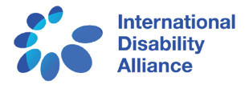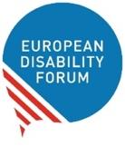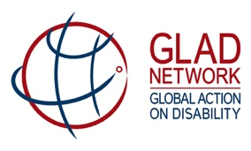

Call to Action – Implementation of the Disability Inclusion marker
The Disability Movement, represented by the International Disability Alliance (IDA), the European Disability Forum (EDF) and the International Disability and Development Consortium (IDDC), has long advocated for better disability-disaggregated data in development assistance and humanitarian action.
We therefore strongly welcome the introduction in June 2018 by the Development Assistance Committee (DAC) Working Party for Development Finance Statistics of an OECD DAC policy marker ‘to track development finance in support of persons with disabilities’ (hereafter referred to the as the disability inclusion marker). This marker is a crucial contribution to improving the availability and quality of data collected on disability in relation to Overseas Development Assistance (ODA).
We note that, due to concerns over the overall number of markers and an upcoming review of the systems, the marker is voluntary, not mandatory. Current indications are that the marker will be applied by 9 DAC members in the 2018 reporting period. We encourage all DAC members to adopt the marker.
The inclusion of persons with disabilities is key to achieving Agenda 2030’s ambition to eradicate poverty and leave no-one behind. The UN Convention on the Rights of Persons with Disabilities (CRPD) commits states to ensuring that international cooperation and humanitarian aid is inclusive of and accessible to persons with disabilities.
The disability inclusion marker has a critical role in supporting this. By providing better data on whether interventions are disability inclusive the marker can support donors to understand the current state of play, set targets and take concrete steps towards implementing the CRPD and SDGs.

We call on DAC members to:
- Introduce and apply the disability inclusion policy marker in 2018/2019 ODA reporting and beyond;
- Promote elevating the marker from voluntary to mandatory status;
- Support the development of a handbook to guide the implementation of the marker. The handbook should align with the CRPD, promote the meaningful involvement of persons with disabilities and their representative organisations, and include an expectation that all interventions to assess whether they meet the criteria of ‘doing no harm’;
- Share lessons learnt from the implementation of the marker to support the collection of data that is accurate and comparable;
- Ensure that international development programmes are inclusive of and accessible to persons with disabilities.

