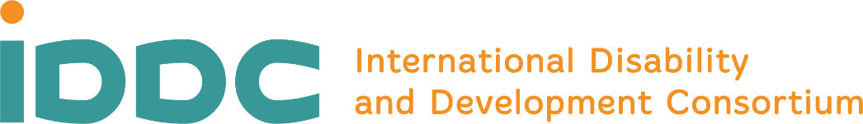

The International Disability and Development Consortium (IDDC) is a global consortium of organisations supporting disability and development work in more than 150 countries around the world. IDDC and its members aim to promote inclusive development internationally, with a special focus on promoting the full and effective enjoyment of human rights by all persons with disabilities living in economically poor communities in lower and middle-income countries.
IDDC is based on several core values and principles: the respect of human rights for all; inclusion and diversity; sustainable development and social justice; partnership, participation, and collaboration. For more info, visit the IDDC website
IDDC is seeking a student or young graduate looking for an intern position focusing on communications for a disability and development network. The successful candidate will be a creative team player, a flexible individual able to work within a multicultural environment and to stick to tight deadlines.
IDDC operates an equal opportunities recruitment process. People with disabilities are strongly encouraged to apply for this position.

Tasks
- Support the drafting of content for IDDC internal and external communication channels, including social media
- Support the creation of IDDC newsletter
- Assist with the production of communication materials (leaflets, reports, etc.)
- Update IDDC’s website (content)
- Assist with the organisational and logistical aspects of IDDC General Assembly and other events where needed
- Attend events and policy debates on selected topics
- Other related tasks as needs arise

Requirements
- A Bachelor or Masters’ degree and/or relevant work experience/volunteering in the field of communication
- Strong writing and creative skills, with the ability to adapt own language to the target audience
- Excellent command of the English language (both spoken and written)
- Very good computer skills and digital literacy, and a knack for visual communication
- Commitment to IDDC Values and Principles
- Strong interest in and commitment to disability and development cooperation
- Excellent interpersonal and communication skills

The following will be considered as assets
- Experience in digital accessibility
- Previous experience in graphic design
- Good command of Adobe Illustrator, Adobe InDesign and Adobe Photoshop
- Knowledge of other communication tools, such as Wordpress, Mailchimp, and Social Media tools
- Knowledge of the disability and development sector and stakeholders, including the Convention on the Rights of Persons with Disabilities and Agenda 2030
- Knowledge of additional languages is a plus

Terms and conditions
- Internship agreement for a maximum duration of 4 months
- Duration of internship: ideally from 16 March 2020 to 24 July 2020
- This will be a full-time internship
- The successful candidate must be eligible to live and work in Belgium
- The intern will receive a monthly allowance
- Applicants are encouraged to apply for Erasmus+ Placement or Stage first through Actiris

How to Apply
Please send your application by Sunday 19 January 2020 to info@iddcconsortium.net. Applications must include curriculum vitae, a one-page motivation letter, and – if available – a portfolio of recent graphic and visual works. Please make sure that your email carries the following subject line: “Application for Communication Intern” and your last name. Interviews will take place on 10-14 February 2020. We regret that we will only be able to send a reply to candidates who have been short-listed for the interviews. We thank you for your understanding. For more details on the terms of the contract, including financial support, please get in touch with IDDC at info@iddcconsortium.net.

