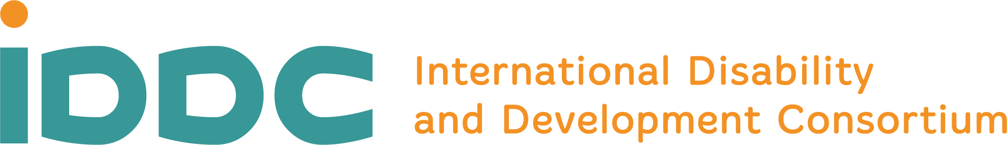

[Inclusive Education Task Group]
[6 April 2020]

IDDC Inclusive Education Task Group response to COVID-19
We are living in unprecedented times, with many countries in the world adjusting to the impact of the COVID-19 outbreak. It is clear that in addition to the impact on health, this outbreak will have a long-term significant impact on the education of children and young people globally.
Already, nearly 90% of children and young people are experiencing disruption to their education and 185 countries have implemented country-wide school closures.

Children with disabilities in education
Children with disabilities were amongst the most likely to be excluded from education, with 50% of children with disabilities in low- and middle-income countries out of school before the pandemic.
During this worldwide health crisis, there is no doubt that the educational situation of all children and young people will worsen – with an increased risk for children with disabilities. Even though, technology offers a solution to some extent, in more developed settings, we need to consider an array of solutions for families with children with disabilities and parents with disabilities. Children who struggle to keep attention, who need material in accessible formats and learn through doing are stuck. The stress on parents is insurmountable as they are juggling childcare/parenting, home-schooling, working from home, financial strain and other personal concerns in this world of uncertainty.

Girls and boys with disabilities often live in some of the poorest families, face discrimination in their communities and are not prioritised in terms of education. The risk of exclusion is even-higher now in this time of crisis. Children with disabilities are also more likely to drop out of school than their peers – and there is a real risk that those who leave school now may not return

Additional, specific challenges in times of school closures
Recognising that school closure is a necessary measure to contain the pandemic, this will nonetheless, have a significant impact on children and young people not only in their education but also in their access to food programmes, social support, personal assistance or medical care, which are often accessed through schools. Children and young persons with disabilities are amongst the most affected, as the break-down of support structures can increase their vulnerability, disrupt protection systems, and expose them to discrimination and violence.
Where schools are closed, alternative arrangements are often made. Countries are adopting different approaches including sharing resources to be used at home, moving education online and using radio, television and mobile phones to send resources. When these approaches are put in place, accessibility for all learners must be considered and their right to education must not be ignored. For example, if teaching happens only via radio transmission, then there must be mechanisms put in place to ensure that children who are deaf or hard of hearing can access the same educational content. Children with intellectual disabilities must be provided with content that is relevant to them and their learning should be supported (for example, by giving guidance to parents or caregivers).
Many state and non-state actors supported work to train teachers on disability inclusion; it is essential to keep these resources and integrate these efforts in the response’s design and implementation.
We need to ensure that all learners’ rights and needs are met, through the effective provision of quality and inclusive education during this health crisis and crucially beyond.

We call on governments and international development actors to ensure that:
- Children and young people who are most likely to be impacted by school closures, such as those with disabilities, are prioritised in responses;
- Alternative education provision is accessible and provides reasonable accommodations based on individual needs;
- There is adequate and sustained financing for inclusive education during, and after, the COVID-19 outbreak;
- Disability inclusion should be mandatory for qualifying for the Global Partnership for Education, Education Cannot Wait and other relevant grants.
- Any initiatives to use technology and media to facilitate learning should be in a variety of accessible formats.
- Organisations with expertise in specialist support to children with disabilities should be given special dispensations to operate during lockdown periods.
- Responses are co-ordinated and cross-sectoral, including across education, health, social protection and WASH;
- Civil society, including organisations of people with disabilities, are consulted and included in responses to COVID-19;
- The voices of children and young people with disabilities, and their caregivers, are heard, and involved in the design and implementation of response plans;
- Teachers and educators are involved in the transition towards alternative education methods for all learners, trained in new modes of delivery, and are protected by their employers;
- Specific actions are taken to ensure that the most marginalised children are effectively included and supported to return to school when schools re-open.

As the Inclusive Education Task Group of IDDC, we seek to ensure that education remains at the forefront of this crisis and is part of the solution! As IDDC we will work closely with partners and support initiatives by the Global Campaign for Education, UN agencies, the Global Partnership for Education, Education Cannot Wait and others to continue to support the provision of education, health and nutrition. We will also share and collate relevant information to support partners to respond and ensure that children with disabilities can access inclusive education in these challenging times and beyond.

UNESCO, Coronavirus School Closures
Education Commission, Learning Generation

