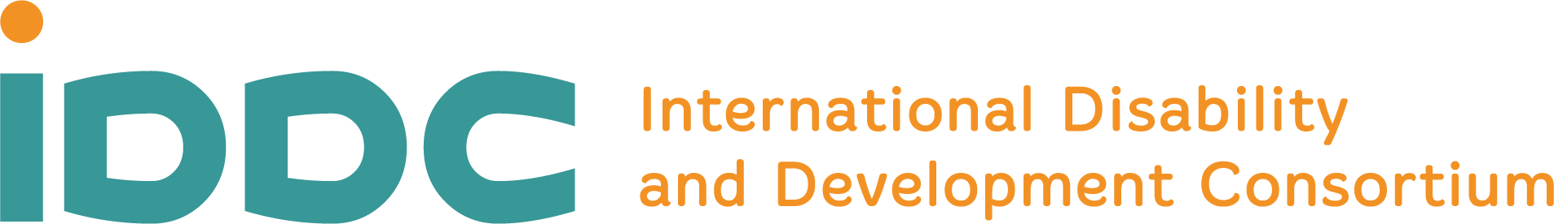

TERMS OF REFERENCE
SHORT-TERM CONSULTANCY ON IDDC SURVEY ON THE EXPERIENCE OF IDDC MEMBER ORGANISATIONS ADAPTING TO THE ONGOING COVID-19 GLOBAL PANDEMIC
About IDDC
The International Disability and Development Consortium (IDDC) is a global consortium of organisations supporting disability and development work in more than 150 countries around the world. IDDC and its members aim to promote inclusive development internationally, with a special focus on promoting the full and effective enjoyment of human rights by all persons with disabilities living in economically poor communities in lower and middle-income countries.
IDDC is based on several core values and principles: the respect of human rights for all; inclusion and diversity; sustainable development and social justice; partnership, participation, and collaboration.
More information about IDDC: www.iddcconsortium.net
Background:
The COVID-19 pandemic and the subsequent emergency measures adopted to curb its spread has has had a huge impact on Civil Society Organisations and our work. IDDC members, partners and communities in countries where we work were no exception and resilience has been put to the test.
IDDC considers there will be a great benefit in learning from an analysing how its member organisations responded and how they adapted working practices to the challenges and threats posed by the COVID-19 pandemic. Conducted as part of the UNPRPD COVID-19 Programme, this survey will enable the collection of information on their experience as well as cases studies and good practices to feed into the work of the UN entities.
The Covid-19 Survey will be developed in collaboration between IDDC, IDA, the PRPD Secretariat and external contributors, such as Social Development Direct as well as UN entities involved in the UNPRPD Covid-19 response. Results will be shared in an accessible and easy to use report.
Services required
IDDC is looking for a consultant to support the development of the survey and the analysis of its findings, and draft a report summarizing those findings along with recommendations. The activities will include the following:
Supporting the development of the survey (up to 3 working days). In this stage, the consultant will support the IDDC Board and Secretariat and consult with key partners in finalising the content of the survey.
Drafting and finalising the survey report (up to 27 working days). In this stage, the consultant will be responsible for data set cleaning, data analysis (including statistical analyses of quantitative data and thematic analysis of responses to open-ended questions), follow-up interviews with respondents whenever relevant and drafting of the report.
The report should summarize the research findings including the following:
- An executive summary including a brief introduction on the objectives and methodology, major findings of the survey along with critical data and recommendations.
- The methodology section detailing the methods of data collections and any gaps and restrictions.
- The main body of the report categorized to different chapters based on major survey findings and priorities set by IDDC.
- Cases studies directly quoted from organisations in the open sections of the questionnaire to be added in chapter and subchapter.
- Figures, tables and charts visualizing survey findings in each chapter along with simple word description of the graphics to ensure accessibility.
- Appendices including more detailed tables, a copy of the questionnaire and any other helpful material.

Timeline: January 2021-March 2021.
Tentative Starting day: January 18, 2021
Tentative end day: March 31, 2021

Qualifications of the consultant
- A degree in public policy, disability studies, human rights, international development, law or equivalent in a relevant field
- Strong research experience and skills in data management
- Knowledge and experience with qualitative and quantitative data analyses
- Familiarity with articulating research findings and dissemination (e.g. data visualizations)
- Commitment to a rights-based approach, and demonstrated interest in and knowledge of the rights of persons with disabilities
- Previous experience with quantitative and qualitative data analysis of surveys of this kind with an international or global scope.
- Excellent written skills and capacity to produce high-quality research and advocacy material in English. Knowledge of other languages will be a plus.
- Excellent time management skills and ability to work independently, with minimum supervision.
- Knowledge of IDDC network will be a plus.
- Persons with disabilities are strongly encouraged to apply.

Contracting and Remuneration:
- Payment and financial compensation will be subject to location and experience;
- A consultancy contract (as per Belgium law) will be signed between the selected consultant and IDDC;
- Applicants are invited to submit a copy of their passport and commercial/consultant registration/tax numbers;
- Payments will be made in several instalments and upon successful completion of the deliverables and submission of invoices.

How to apply
The interested consultant should submit a letter of interest, CV, and financial offer indicating the total fees for 30 working days during the specified timeline latest by January 10, 2021 to coordinator@iddcconsortium.net with the subject “Consultancy application - IDDC COVID 19 Survey”.
Note: Only shortlisted candidates will be contacted.

