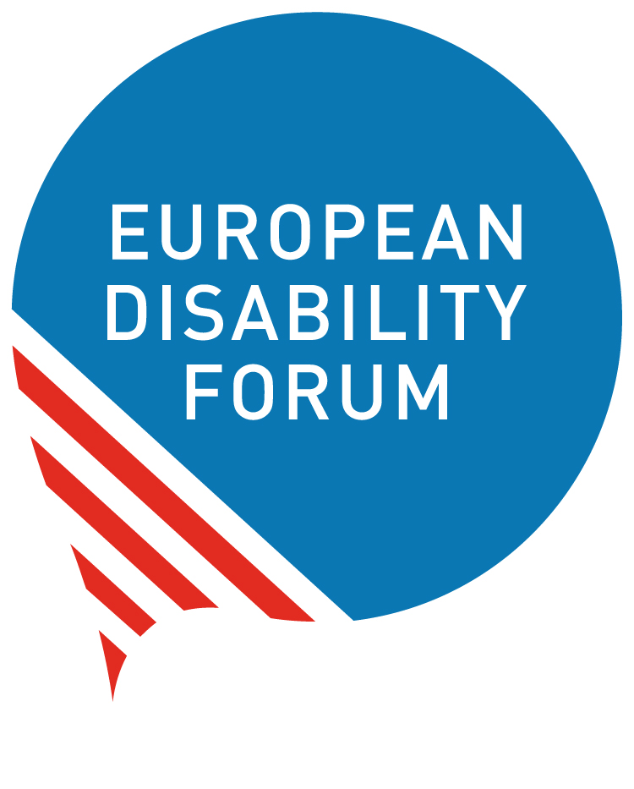

10 February 2021, Brussels

Disability-inclusive programming of EU funding for external action
With this statement we remind the European Commission of its obligations to ensure that women and men, girls and boys with disabilities are not left behind during the programming of the Neighbourhood Development and International Cooperation Instrument (NDICI). All programming must be inclusive of and accessible to persons with disabilities and their representative organisations.
We are prompted to issue this statement following the experience of the disability movement in Myanmar who noted a lack of reference to disability in the EU Delegation’s (EUD) briefing documents and who were not able to fully participate in the programming consultation. It is our hope that the European Commission will remind the EUDs responsible for developing the programming documents of their obligations.
As the EU defines its priorities and programmes funding for external action through the geographic and thematic programmes of the Neighbourhood, Development and International Cooperation Instrument (NDICI), we, the European Disability Forum (EDF) and the International Disability and Development Consortium (IDDC), call on the EU to ensure that the ongoing programming of the NDICI is disability-inclusive and compliant with the EU’s obligations under the UN Convention on the Rights of Persons with Disabilities (CRPD).
The EU and EU Member States, as State Parties to the CRPD, have a responsibility to ensure that all policies and programmes related to EU external action, international cooperation and humanitarian action are inclusive of and accessible to persons with disabilities. During the EU’s review by the UN Committee on the Rights of Persons with Disabilities in 2015, the Concluding Observations on Article 32 (International cooperation) were to: adopt a harmonised policy on disability-inclusive development and establish a systematic approach to mainstream the rights of persons with disabilities in all international cooperation policies and programmes; appoint disability focal points in related institutions; take the lead in the implementation of disability-inclusive Sustainable Development Goals (SDGs); and put in place mechanisms to disaggregate data on disability in order to monitor the rights of persons with disabilities in EU development cooperation programmes.
We recognise the strong commitments made by the EU to promote and protect human rights, democracy, and the rule of law in its external action – applying a rights-based approach as well as the principles of equality and solidarity, through dialogue and cooperation with partner countries, regions, local authorities and civil society. The 2017 EU Consensus for Development, binding for both the EU and its Member States, referred for the first time to persons with disabilities and the CRPD. We also acknowledge stronger references to the EU’s CRPD obligations in recent policies and frameworks related to EU external action, international cooperation and humanitarian action. We hope that the next European Disability Rights Strategy 2021-2030 will strengthen the EU’s current commitments to the disability-inclusive, CRPD-compliant implementation of the 2030 Agenda, the Agenda for Humanity and the Paris Agreement on Climate Change, and ensure coherence across all the EU’s policies and programmes related to external action and international cooperation.
Persons with disabilities account for 15% of the world’s population. More than 80% are living in poverty, with an estimated 800 million persons with disabilities living in developing countries. To ensure that women and men, girls and boys with disabilities are not left behind during the programming of the NDICI, all geographic and thematic programming must adopt a disability inclusive and intersectional approach, across all sectors, and for all the European Commission’s policy priority areas.
EDF and IDDC see the following as key for the inclusive programming of the NDICI:
- Ensure accessible and meaningful participation of persons with disabilities and their representative organisations (DPOs / OPDs) at all stages in the design, implementation and monitoring of the NDICI, and at all levels (regional and country).
- Refer explicitly to the UN Convention on the Rights of Persons with Disabilities (CRPD) and to persons with disabilities in all documentation related to the NDICI including key programming documents such as the geographic (country and regional) and the thematic multi annual action plans (MAAPs), the multi-annual indicative programmes (MIPs) and subsequent action plans.
- Ensure that the ongoing Team Europe global response to COVID-19, as well as all future Team Europe initiatives, and joint programming, implementation and vaccination plans, leave no one behind. Disability inclusion is critical to address all forms of inequality, and to truly build back better Team Europe must follow a human rights-based approach which is disability-inclusive and takes into account the rights of the most excluded groups of persons with disabilities.
- Ensure coherence between the NDICI programming (both geographic and thematic pillars) and the next European Disability Rights Strategy 2021-2030. Coherence is also needed between programming at the implementation of other key polices and frameworks which refer to the CRPD, including the EU Action Plan on Human Rights and Democracy 2020-2024, the EU Gender Action Plan III 2021-2025, the ECHO Guidance Note on the Inclusion of Persons with Disabilities in EU-funded Humanitarian Aid Operations, and the future EU-Africa Strategy (non-exhaustive list).
- Apply a twin-tack approach to disability-inclusion in development and international cooperation which consists of (a) mainstreaming the rights of persons with disabilities of all ages, and (b) initiatives targeting persons with disabilities.
- Use an intersectional analysis to support the design and implementation of programmes, ensure the systematic collection of data disaggregated by at least gender, age and disability, and invest in support to EUDs and partner countries to disaggregate data.

Contact persons in EDF and IDDC:
EDF - An-Sofie Leenknecht, Human Rights Coordinator, ansofie.leenknecht@edf-feph.org
IDDC - Sarah Hull, IDDC EU Task Group Coordinator, s.hull@light-for-the-world.org

