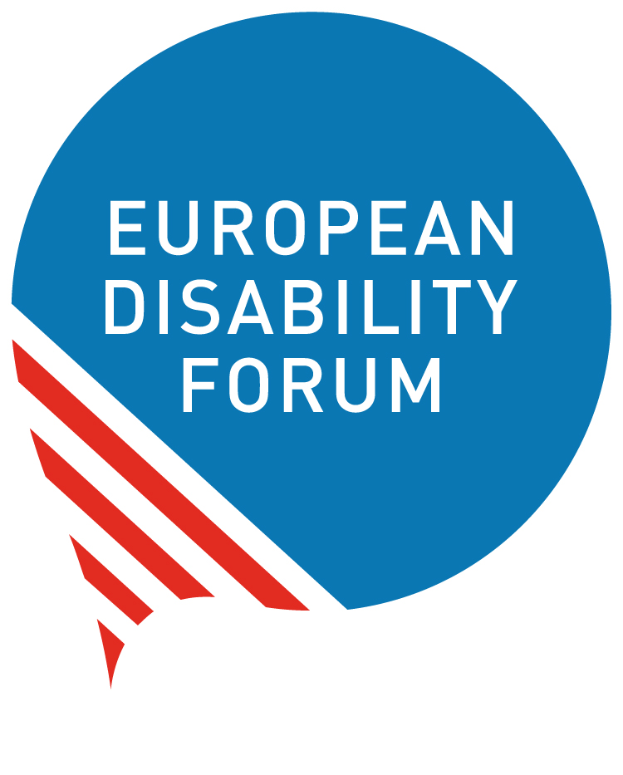

Joint Analysis “Union of Equality: Strategy for the rights of persons with disabilities 2021-2030”

Focus on EU’s external action “Promoting the rights of persons with disabilities globally” (Section 6)

Introduction
The European Disability Forum (EDF) and the International Disability and Development Consortium (IDDC) advocate for the rights of persons with disabilities. The European Union (EU)’s 10-year Strategy for the Rights of Persons with Disabilities, Union of Equality: Strategy for the rights of persons with disabilities 2021-2030, is a fundamental piece of the puzzle forming the vision and guiding the action of the EU, to ensure the rights of persons with disabilities, here in Europe and outside are respected, protected and fulfilled. The Strategy must enable the EU institutions and the Member States to take the most relevant actions to generate the most needed changes for eventually having a positive impact on millions of people around the world. The stakes are high! Persons with disabilities represent 15% of the world population, and 80% of them live in low- and middle-income countries, many of whom are caught in the vicious circle of disability-poverty.
Over the years EDF and IDDC have been engaged in dialogue with EU policy-makers, exposed situations, shared evidence, formulated recommendations; we have also specifically contributed to the consultations leading to this Strategy.
Focusing on Section 6 of the Strategy, relating to the EU’s external action, our overall conclusion is that the Strategy is incomplete and inconsistent, offering a disorganised and too narrow vision of the role the EU should take, and falling short on the specifics, with no clear timeline. The positive initiatives are patchy and disconnected from one another. Above all, many elements put forward in the Strategy are already in place, denying the fact that without any new ambition, and new resources, these are not going to deliver better results. Since the adoption of the Organisation for Economic Co-operation and Development (OECD) Development Assistance Committee (DAC) marker on disability by the EU, the proportion of new EU-funded projects that mainstream disability or address disability as their main focus remains very low.
With this analysis, we present our key proposals and recommendations to reinforce the Strategy’s external action component.
This paper summarises our proposals and recommendations around four priorities: meaningful participation, coordination, means of implementation, and leadership. The Annex (see full document online, or also available on request) contains deeper analysis on these topics, as well as additional recommendations.

Our Priority Recommendations for a more Impactful Strategy

Operationalise Meaningful Participation
The effective and meaningful participation of persons with disabilities and their representative organisations (DPOs) is an obligation under the UN Convention on the Rights of Persons with Disabilities (CRPD). As civil society actors representing the interest of a specific group of people, DPOs must be consulted in policy-making processes. But DPOs must also be enabled in the role of project-implementing partners, and involved in the planning, implementation and monitoring of EU programmes that concern them.
While the Strategy rightly underlines the importance of involving organisations of persons with disabilities, it fails to grasp all the forms such involvement should take, as it mainly focuses on the consultative role.
Accessibility is a primary requirement to ensure the meaningful participation of persons with disabilities and their representative organisations. No EU public money should be spent without guarantee that accessibility standards are respected.
EDF and IDDC recommend to:
- set up a specific and inclusive process, a ‘structured dialogue’, to ensure participation of representative DPOs in the implementation and monitoring of the Strategy. This dialogue should take place in all relevant processes at EU, partner countries and global level, including in all EU overseas delegations, with an independent budget line and sufficient funding (in line with Article 11(2) of the Treaty on European Union, Article 4(3) of the CRPD and General Comment No. 7 of the CRPD Committee).
- invest rapidly in making all EU Delegations fully accessible to and inclusive of persons with disabilities.
- introduce a standard accessibility requirement in the EU public procurement rules, and for all contractors and implementing partners of EU-funded programmes.
- include DPOs in the EU Delegations’ local and regional civil society dialogues.
- enable DPOs to access funding with, for instance, the creation of an intermediate body that allows these funds to be distributed among smaller organisations. This funding should provide technical, capacity-building, and training, as well as specific financial support to allow DPOs to sustainably build their governance structures and human resources. This would enable them to develop relevant expertise, to sit as equal partners around the table, and to meaningfully contribute to the Strategy and all relevant external action policy planning, funding programmes and activities.

Ensure capacity and effective coordination
The Commission needs to move away from the current system of under-resourced disability focal points, which is not effective. It is hoped that the new ‘disability coordinators’ mentioned in the Strategy, who will be nominated in all European Commission’s Directorate Generals (DGs), EU External Action Service (EEAS), EU Delegations (EUDs) and other bodies and agencies, will be more effective, as they should play a key role to ensure the coherent implementation of the Strategy in line with the CRPD.

EDF and IDDC recommend that:
- ‘disability coordinators’ actively involve DPOs in their work. A list of ‘disability coordinators’ should be publicly available, as it would improve transparency and accountability.
- each ‘disability coordinator’ has sufficient human and financial resources.
- ‘disability coordinators’ focusing on EU external action actively participate in the work of the new Disability Platform, to be established in 2021.
- the new Disability Platform puts issues related to external action, development cooperation and partnerships, and humanitarian action on its agenda, and involves DPOs.
- a CRPD unit (focal point) is created under the direct supervision of the Commissioner for Equality. It should be responsible for coordinating the work of all ‘disability coordinators’ and all external EUDs regarding the implementation of the Strategy and the CRPD.
Progress on disability-inclusive international cooperation will only happen when all actors involved are sensitised and incentivised to do it. Too little attention is given to capacity building in the Strategy.
EDF and IDDC recommend:
- more investment in regular training and capacity building for EU staff, including the ‘disability coordinators’, EUDs, DG European Civil Protection and Humanitarian Aid Operations (ECHO) field staff, and also for EU Member State agencies in partner countries, on the implementation of the Strategy and the CPRD,
- to extend training / capacity building to implementing partners, including NGOs and DPOs, with the view notably to improve their practices for disability inclusion in mainstreamed and targeted actions.

Provide means of implementation
Without framework and means for implementing and monitoring, the Strategy will be meaningless. Further details are now needed to establish plans for concrete actions, targets and indicators, and clear timelines, combined with an allocation of roles and responsibilities.
Using the OECD DAC disability policy marker to track disability-inclusive investments should be very useful to monitor progress, especially if the marker is applied consistently across the European Commission’s wide portfolio of programmes.
More efforts to produce, collect, and analyse inclusive and intersectional data disaggregated by at least gender, age, and disability is needed to incentivise and support evidence-based disability-inclusive policy making and aid programming.
The immediate test for the Strategy’s implementation is the ongoing process of programming relating to the Neighbourhood, Development and International Cooperation Instrument (NDICI) - Global Europe Instrument, including Team Europe’s joint programming. The European Commission and the EU Member States must ensure that no EU aid is spent on any action that would jeopardise the rights of persons with disabilities; on the contrary it should enable these individuals to fully enjoy their rights.
EDF and IDDC recommend to:
- adopt an EU action plan for its external action on promoting and respecting the rights of persons with disabilities, including appropriate resources and how it will support partner countries to implement the CRPD.
- ensure that development and humanitarian aid programming is CRPD-compliant, and both inclusive of and accessible to persons with disabilities and DPOs.
- systematically use an intersectional approach and analysis to support the design and implementation of EU programmes in partner countries.
- provide concrete and clear guidance to all relevant EU Directorates and services, including EU Delegations, on how to systematically apply the disability marker across their programmes, and encourage EU Member States to do the same, including through the Team Europe approach in partner countries.
- ensure that future recommendations (Concluding Observations) by the Committee on the Rights of Persons with Disabilities on the EU’s implementation of CRPD Articles 11 and 32 are taken up in a mid-term review of the Strategy.

Apply leadership where it can make a change
Given the position of the EU as the only regional body having ratified the CRPD, one of the largest donors of overseas development assistance (ODA), and a major trade partner of so many developing countries, the EU must lead by example and must apply its leadership as a champion of the rights of persons with disabilities where there is the greatest added value to generate substantial changes.
EDF and IDDC recommend that:
- urgently, the EU demonstrates leadership to promote the rights of persons with disabilities in global discussions relating to the access to COVID-19 vaccination, and more globally to the COVID-19-response and recovery plans.
- the EU commits to holding dialogues on disability rights with partners involved in the EU-Africa Strategy, Eastern partnerships post-2020 and EU’s engagement in Western Balkans, and ensuring these frameworks are implemented in full compliance with the CRPD.
- the EU promotes much more systematic disability mainstreaming in the monitoring and reporting mechanisms of the Agenda 2030, including at the High-Level Political Forum.
- the EU supports and gets involved at the highest level in the recurrent Global Disability Summit, and proposes to co-host one such Summit within the 10 years of the Strategy.
- the European Commission and the Member States further engage in the Global Action on Disability (GLAD) network with a view to promote disability-inclusive donors’ policies and practices. As one of the largest donors of ODA, the EU can only consolidate its credibility as a global disability rights champion, by being also a disability rights aid champion.
- the EU and its Member States oppose the adoption of any laws or policies at the Council of Europe that do not comply with the CRPD.

Under 15% in 2020 - exact figure will be reported in the upcoming OECD DAC annual results report.

