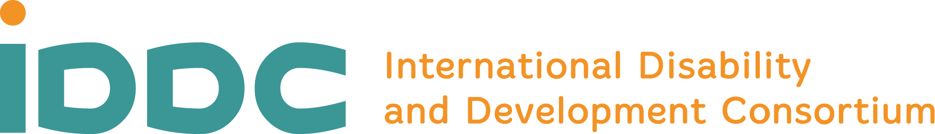

Science offered sound evidence about the negative outcomes of the climate crisis and environmental degradation for human health and wellbeing. It is also known that some groups, and, among them, persons with disabilities, are most at risk of suffering the consequences of climate change. However, until the COP26, climate scientists, policymakers, and the disability-inclusion movement had not many occasions to meet and speak. Because of its focus on diversity and equity, the Planetary Health approach offers a safe framework for enriching the narrative with a wide range of voices, needs, skills, and solutions for a common challenge and, ultimately, nourishing climate action leaving no one behind.

The 5th Planetary Health Annual Meeting is the perfect place for students, scientists, policymakers, civil-society, artists, private-sector representatives, and others to address health determinants’ complex relationships, seek solutions, and build skills for inclusive climate action.

The IDDC side event is entitled “Planetary Health dialogue on inclusion” and we hope it opens and facilitates a dialogue between planetary health researchers, INGOs, OPDs and practitioners with persons with disabilities who are the best experts for ensuring meaningful participation.

Join us on the 31st of Oct at 9:15am ET/3:15pm CET on Zoom. Register in advance for this meeting:
https://us02web.zoom.us/meeting/register/tZUlde-prT8sGNep0Jx-jgwkHwCUhHAtfNdF
After registering, you will receive a confirmation email containing information about joining the meeting.

31 Oct
09:15 – 09:30 am ET /3:15pm CET | Panel 1: Setting the scene  Interventions by:  - Mary Keogh, Co-chair IDDC TG on Climate Action  - Davide Ziveri, Co-chair IDDC TG on Climate Action  - Representative from CBM Global Disability Inclusion
09:30 - 10:15am ET  10:15 – 10:30am ET | Panel 2: The views of civil society organisations and OPD’s  Moderator: Fernando Mauricio Carvalho, PG DIS Member  Interventions by:  - Representative from HI  - An-Sophie, European Disability Forum  - Muhammad Asaduzzaman, Planetary Health working group of Be-Cause Health.  Q&A
10:30 – 10:45am ET | Closing remarks by IDDC Co-Chairs and Guests

Participants can speak
Sign language and Captioning confirmed
Please find the PHA annual meeting full program here: https://www.planetaryhealthannualmeeting.com/

