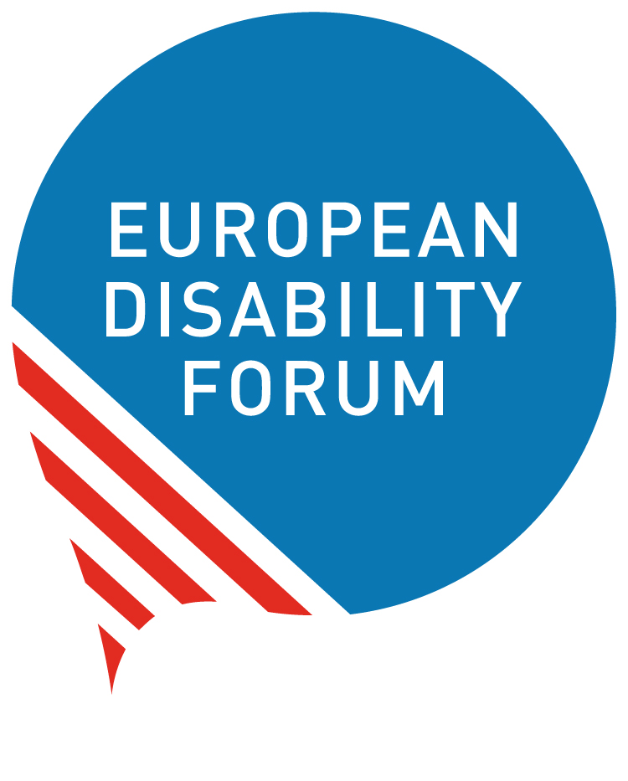

Release of the new EU Guidance note on the inclusion of persons with disabilities in EU global actions
  - Joint reaction by EDF and IDDC
28th March 2023
The European Disability Forum (EDF) and the International Disability and Development Consortium (IDDC) welcome the new European Union Guidance Note on "Leaving no one behind - Disability Inclusion in EU External Action”. With this new publication, the EU recognises the need for its staff and delegations around the world to further work on the implementation of the UN Convention on the Rights of Persons with Disabilities (CRPD), which the EU ratified in 2010. It acknowledges that disability inclusion is essential to achieve sustainable development, peace, and human rights in the world.
This guidance note is a welcome example of the EU’s increasing efforts to promoting disability-inclusive development in policies and programmes, ensuring that persons with disabilities are not left behind in EU external action. We also take notice of the two technical briefs within the guidance note on Disability Inclusion, Gender Equality and Women’s Empowerment and Disability Inclusion and Climate priorities. We commend the EU’s participation in and commitments made at the Global Disability Summit 2022, and its decision to co-host in Brussels the next global meeting of the GLAD Network, the network of donors and other stakeholders with a focus on disability inclusion. We praise the EU use of the Organisation for Economic Cooperation and Development’s Development Assistance Committee (OECD-DAC) disability marker to 100% of all its Overseas Development Assistance (ODA).
This guidance note will deliver improved practices only if it is properly rolled out, implemented, and resourced. This requires investments in training of EU staff working in EU external action, and the appointment of disability focal points in delegations. This also calls for strengthening the dialogue with OPDs, and their meaningful participation in broader structured dialogue with civil society, both at Headquarters and delegation levels. EDF and IDDC stand ready to support the EU in this process.
It will be important to monitor the use of the Guidance Note and update it regularly, based on lessons learned and future recommendations by the UN Committee on the Rights of Persons with Disabilities.
In order to have a clear roadmap for all internal and external stakeholders, we urge the EU to adopt an action plan for its external action on promoting and respecting the rights of persons with disabilities, including appropriate resources and how it will support partner countries to implement the CRPD. By working together, we can create a more inclusive and sustainable world for all.
More information:
- Marion Steff, International Cooperation Manager, marion.steff@edf-feph.org
- Sarah Hull, IDDC EU Task Group Coordinator, s.hull@light-for-the-world.org
Other resources:
EDF two new toolkits (2023):
- one for DPOs on how to engage with the EU Delegations around the world
- one for EU Delegations on how to work with DPOs.

