Universal Health Coverage must leave no one behind: a call for action to advance health equity for persons with disabilities and older people in the new political declaration on UHC
A briefing from the International Disability and Development Consortium (IDDC), April 2023
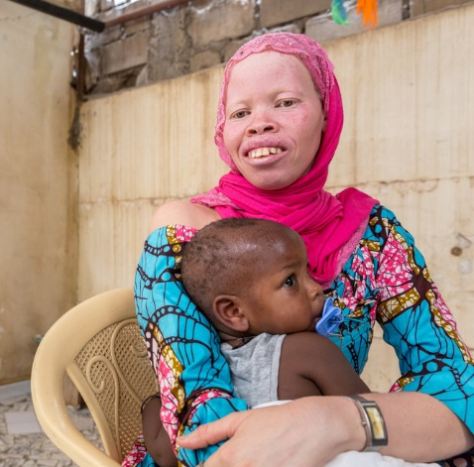 | 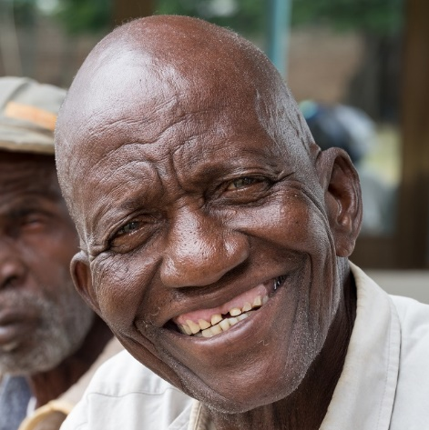 | 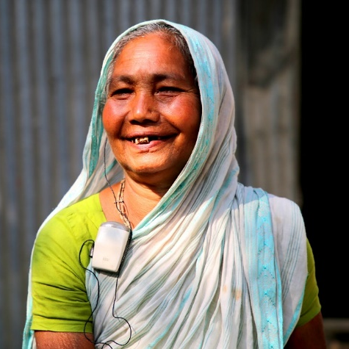
© Sightsavers / Javier Acebal | © CBM / Hayduk | © Humanity & Inclusion / Farid Khan

Background
An estimated 1.3 billion people – or 1 in 6 persons – experience significant disability, 80% of whom live in low-income and middle-income countries. This figure is rising due to population ageing and escalating prevalence and complexity of poverty-related, non-communicable and communicable diseases. World Health Organization (WHO) estimates 5.8% of children and adolescents have a disability, rising to 34.4% among older people. Across all age groups, more women experience disabilities than men (18% compared with 14.2%).
Persistent health inequities mean that persons with disabilities face, on average, much poorer health and functioning than the general population. Persons with disabilities have 2.4-fold higher mortality rates than those without disabilities and they are missing 10 to 20 years of life expectancy. These inequities result from a combination of structural factors, social determinants of health, health-related risks and health system factors that disproportionately impact on persons with disabilities and older people.
Different social factors and characteristics such as gender, age, race and poverty interact powerfully with disability to influence health inequities among persons with disabilities. For example, women and girls with disabilities are disproportionately exposed to discrimination and other barriers in accessing healthcare (including sexual and reproductive health services) and are more exposed to stigmatization, violence and human rights abuses such as forced sterilization or abortion. Ageism often leads to older persons with disabilities being excluded from services or facing a shorter lifespan, cognitive decline, increased social isolation, loneliness, poverty, violence and abuse. Indigenous persons with disabilities often experience multiple layers of discrimination and barriers to the full enjoyment of their health. Race, ethnicity and racial discrimination also affect the experiences and participation of persons with disabilities in health systems. Migrants, refugees, asylum-seekers and internally displaced persons with disabilities are also at greater risk due to exclusion from national health systems and many other barriers to realizing their right to health.
See WHO (2022) Global report on health equity for persons with disabilities, p.25 & pp. 84-87.
Interaction of disability with other drivers of health inequity (‘intersectionality’)
The 2019 UN Political Declaration on Universal Health Coverage (UHC) included a commitment to increase access to health services for persons with disabilities, remove barriers, provide quality standard of care and scale up efforts for their empowerment and inclusion. It also committed governments to scale up efforts to promote healthy and active ageing and respond to the need for promotive, preventive, curative, rehabilitative, palliative and specialized care through a life-course approach and long-term care and support.
Yet, still today, persons with disabilities and older people face unjust and unfair barriers in accessing healthcare. These include financial barriers; physical barriers related to infrastructure, equipment and transportation not being accessible; communication barriers, such as health information not being provided in accessible formats; and attitudinal barriers, including discrimination and lack of knowledge on disability issues amongst health workers.
Persons with disabilities are three times more likely to be denied healthcare, four times more likely to be treated badly in healthcare facilities, and twice as likely to find facilities or healthcare providers’ skills inadequate. They are also more likely to find healthcare unaffordable and face catastrophic health expenditure than other people.
Persons with psychosocial disabilities and intellectual disabilities are among the most left behind in UHC, with limited choices of support and services for their mental health and well-being and often experiencing restricted rights and human rights abuses in residential and long-term facilities, such as involuntary treatment and detention.
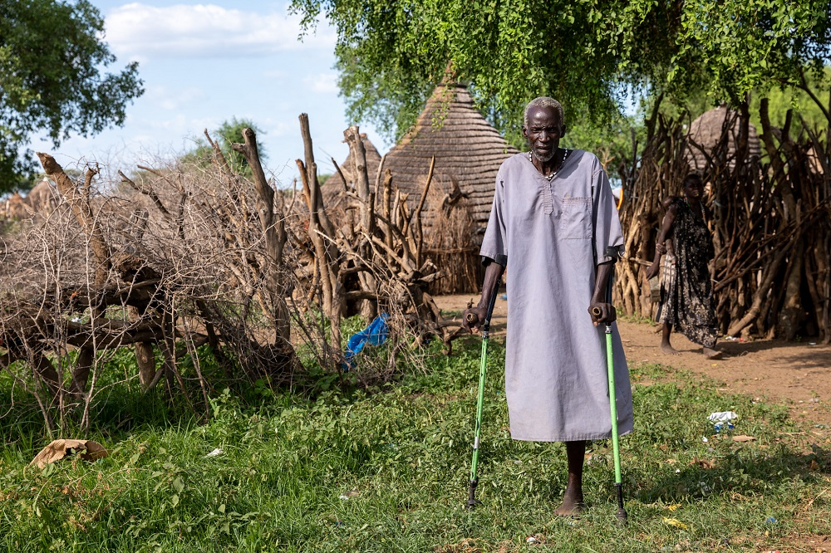
© HelpAge / Brayden Howie
These inequities are greatly intensified in health emergencies. Persons with disabilities have been almost 3 times more likely to die from COVID-19 globally. COVID-19 infection rates have been 4–5 times higher among persons with disabilities living in residential or long-term care facilities compared with the general population; persons with intellectual disabilities have been 4–5 times more likely to be require hospitalization, and up to 8 times more likely to die from COVID-19 than those without an intellectual disability.
Intersecting factors such as sex, age, gender identity, poverty or migrant status further intensify health inequities experienced by persons with disabilities, often as a result of multiple forms of discrimination that remain poorly addressed in health systems and services. For instance, women with disabilities are three times more likely to have unmet health care needs than men, and for older persons with disabilities, ageism is often reflected in greater levels of poverty and exclusion from services, a shorter lifespan, cognitive decline, increased social isolation and loneliness, and a higher risk of experiencing violence and abuse (see text box above).
UHC can only be achieved if health inequities experienced by persons with disabilities and older people are fully addressed.
Advancing UHC will depend on concerted action to tackle these inequities across the continuum of healthcare and across the life course, with specific investments to prioritize people with the greatest needs who are furthest behind, as committed to by governments through the 2019 political declaration on UHC.
The International Covenant on Economic, Social and Cultural Rights (ICESCR) codifies the right of everyone to the enjoyment of the highest attainable standard of physical and mental health as a fundamental right of every person without distinction of any kind. The Convention on the Rights of Persons with Disabilities further commits States Parties to recognize that persons with disabilities have the right to the enjoyment of the highest attainable standard of health without discrimination on the basis of disability, and to take all appropriate measures to ensure access for persons with disabilities to health services that are gender-sensitive, including health-related rehabilitation.
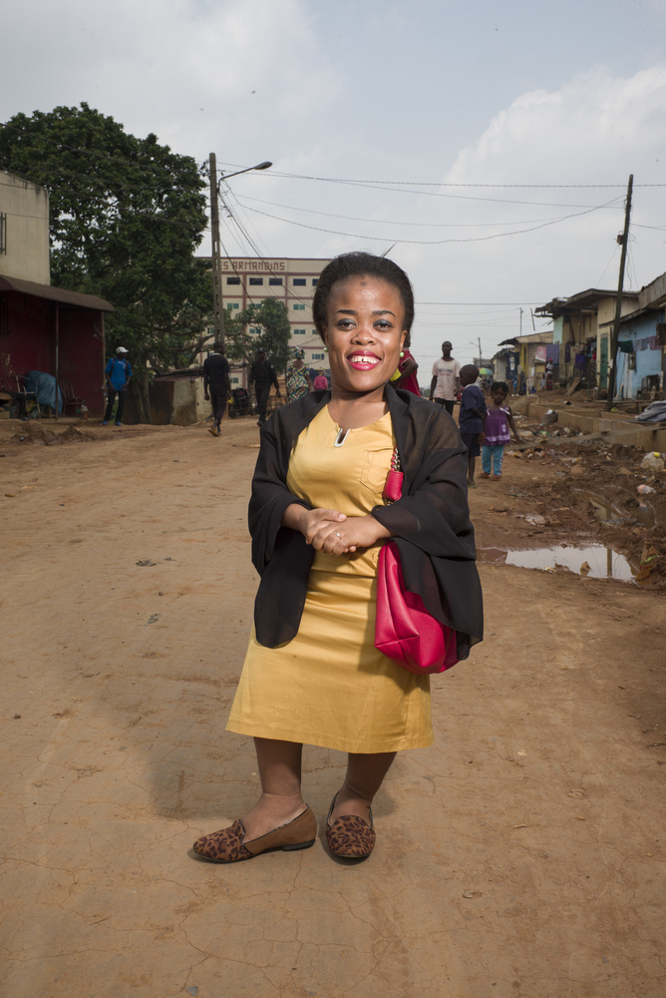
© Sightsavers / Graeme Robertson
Fulfillment of the right to the highest attainable standard of health for every person and the promises made in the 2019 political declaration on UHC on urgent action by governments.

Action needed to advance health equity for persons with disabilities of all ages

As UN Member States prepare to negotiate, adopt, and implement a new Political Declaration on UHC, we urge Heads of State and health decision-makers to commit to:

1 | Provide political leadership to promote health equity for persons with disabilities of all ages. Prioritize health equity for persons with disabilities and formalize commitments and governance mechanisms for disability inclusion through policies and legislation that protect the right to health, prohibit discrimination and demand reasonable adjustments for persons with disabilities.
2 | Make health systems, services and facilities more inclusive to benefit everyone and leave no one behind by investing in universal design, community-based, person-centered and whole-of-society approaches founded upon primary healthcare and essential public health functions, ensuring that health and care services are accessible to all and close to where people live.
3 | Promote a human rights-based approach to health and UHC. Ensure progress towards UHC upholds the right of persons with disabilities to available, accessible, acceptable and quality health related goods, facilities and services, their right to participation in health-related decision-making processes and to non-discrimination, to ensure their enjoyment of the right to health on an equal basis with others. Guarantee free and informed consent and bodily autonomy for persons with disabilities of all ages.
4 | Develop competencies for disability inclusion for the health workforce and provide training in disability inclusion for all health service providers. This should include both mandatory pre-service disability inclusion training integrated within teaching curricula of health training institutions, as well as in-person training as part of continuous professional development plans for health and social workers.
5 | Ensure progressive universalism and inclusive health financing in advancing UHC to eliminate the additional financial barriers that persons with disabilities and older people face in realizing their right to health. This should include testing and scaling-up solutions to reduce out-of-pocket expenditure for those who cannot afford it, while expanding access to health insurance and other community support systems, ensuring that essential services and additional costs for persons with disabilities are also covered.
6 | Advance inclusive health governance, with specific mechanisms that ensure the meaningful engagement of persons with disabilities of all ages, including women and girls with disabilities and older people, and their representative organizations at all levels in health and care policy planning, implementation, monitoring and evaluation. Ensure disability-inclusive policy development, service design and feedback mechanisms for quality of health and care services and consider the specific requirements of persons with disabilities in systems to monitor care pathways.
7 | Prioritize access, inclusion and rights of persons with disabilities of all ages who are at higher risk of intersecting forms of discrimination and disadvantage or who are most exposed to negative social determinants of health. Ensure specific action to identify, include and fulfil the right to health for women and girls, children and older persons with disabilities, those living in poverty, and those who are displaced or in remote or insecure contexts.
8 | Prioritize equity, inclusion, meaningful participation and protection of persons with disabilities and older people and their right to the highest attainable standard of health in health emergency and disaster preparedness, response and recovery plans, including the prohibition of discrimination in the provision of healthcare, services or assistance on the basis of disability or age, ensuring continuing access to essential health products, services and facilities, and the continuation of support in the community.
9 | Ensure UHC service packages enable persons with disabilities of all ages to enjoy their right to available, accessible, acceptable and quality goods, facilities, services and information that meet their physical and mental health needs across the full continuum of care and throughout the life course. This must ensure expanded coverage of sexual and reproductive health services, health information, nutrition services, communicable and non-communicable disease prevention and care, immunization, rehabilitation and assistive products, palliative and end of life care, and integrated long-term care and support within the community.
10 | Promote deinstitutionalization for persons with disabilities of all ages and increase investment in community-based health and care services and support systems, including mental health services, which promote recovery, participation, and rights-based support.
1100 | Remove upper age caps and collect, analyze, report and use sex-, age- and disability-disaggregated data on people of all ages to inform equity-based service design and delivery and decision-making in health to ensure progress towards universal population, service and financial coverage. This should be based on reaching those with the greatest need who are the furthest behind first and linked to clear accountability measures.
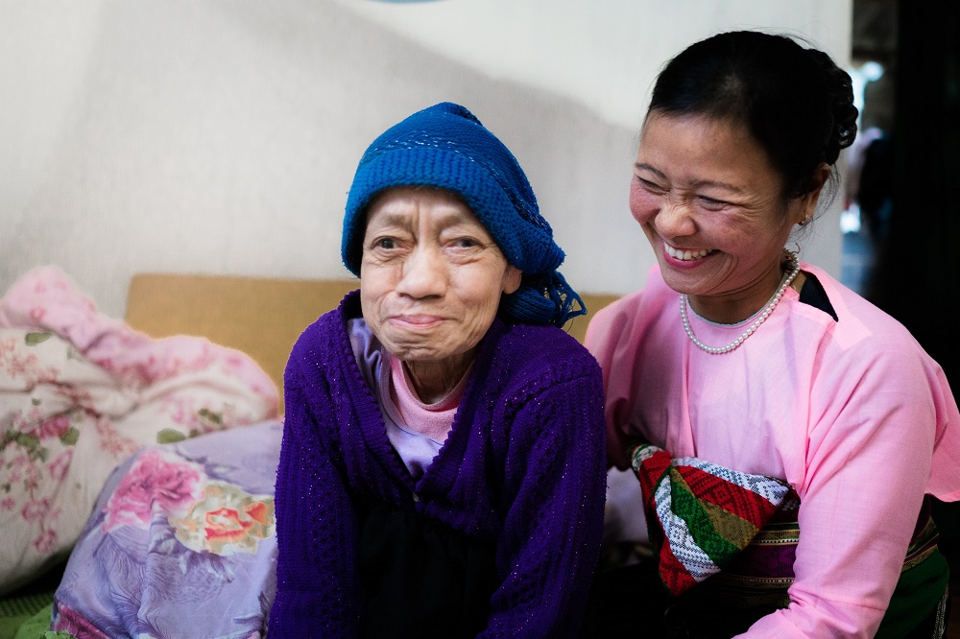
© HelpAge / Brayden Howie

Annex I: Recommended wording for the political declaration on UHC, incorporating agreed language from WHA resolutions 74.8 and 73.1 and UN General Assembly resolutions 74/2 (Political Declaration on UHC) and 75/154 (Inclusive development for and with persons with disabilities)
The following section outlines language from existing World Health Assembly and UN General Assembly resolutions to inform drafting of the UHC political declaration to be adopted at the High-Level Meeting on UHC in September 2023.
We, Heads of State and Government and Representatives of States and Governments….:
Recall resolution WHA71.8 of 26th May 2018 entitled ‘Improving access to assistive technology’; resolution WHA72.3 of 24th May 2019 entitled ‘Community health workers delivering primary healthcare: opportunities and challenges’; and resolution WHA74.8 of 31st May 2021 entitled “The highest attainable standard of health for persons with disabilities”;
Note the WHO global report on health equity for persons with disabilities;
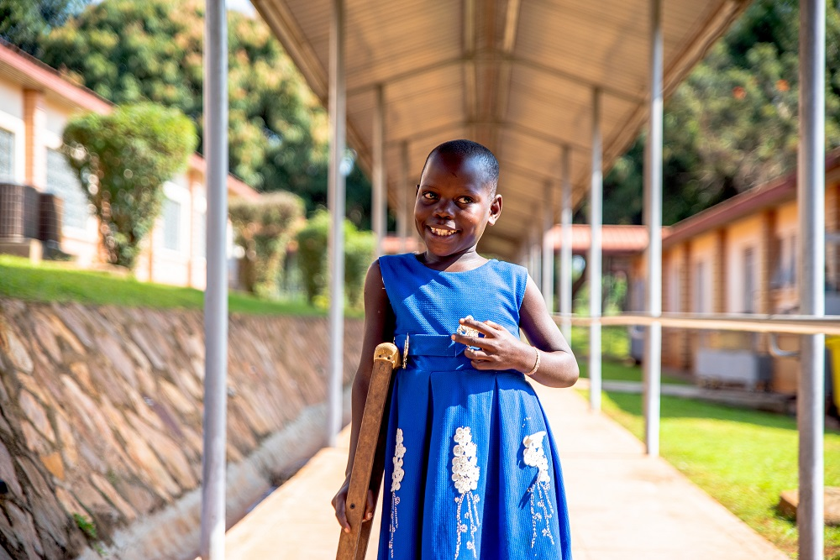
© CBM
Recall resolution WHA73.1 of 19th May 2020 entitled ‘COVID-19 response’;
Reaffirm General Assembly Resolution 75/131 of 14 December 2020 entitled “United Nations Decade of Healthy Ageing (2021–2030)”;
[Note that] globally one in seven [six] persons experience some form of disability and that this number continues to increase owing to many underlying factors such as population ageing and the rise in the prevalence of chronic health conditions; [WHA74.8]
[Note] also with concern that persons with disabilities [of all ages] face persistent inequality in social, economic, health and political spheres, and thus are more likely to live in poverty than persons without disabilities; and that they are more likely to have risk factors for non-communicable diseases; as well as being more likely to be unable to get access to essential health services, public health functions, medicines and treatment, due to environmental, financial, legal and attitudinal barriers in society, including discrimination and stigmatization, as well as lack of reliable and comparable data; [WHA74.8]
[Note] that persons with disabilities, in particular women, children, youth, persons with albinism, indigenous peoples and older persons, continue to be subject to multiple, aggravated and intersecting forms of discrimination, and noting that, while progress has already been made by Governments, the international community and the United Nations system in mainstreaming disability, in particular the rights of persons with disabilities, as an integral part of the development agenda, major challenges remain. [A/Res/75/154]
[Further note] that women and girls with disabilities are often among the most vulnerable and marginalized in society, and recognizing the need for national development strategies and efforts to promote gender equality and the empowerment of women and girls with disabilities and the realization of their human rights. [A/Res/75/154]
[Further note that] many persons with disabilities, particularly girls and women, face barriers to access information and education, including with regard to sexual and reproductive health and reproductive rights as agreed in accordance with the Programme of Action of the International Conference on Population and Development and the Beijing Platform for Action and the outcome documents of their review conferences; [WHA74.8]
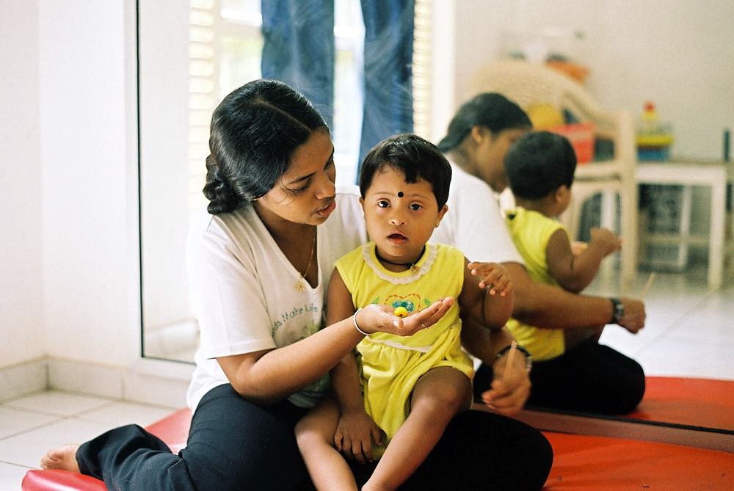
© Humanity & Inclusion / Merchez
[Recognize] that, as many persons with disabilities [of all ages] face multiple and intersecting forms of discrimination and are therefore at greater risk of having unmet health needs, health and rehabilitation interventions should take into account different needs and be age-sensitive and gender-responsive while promoting, protecting and ensuring the full and equal enjoyment of all human rights and fundamental freedoms by all persons with disabilities, and promoting respect for their inherent dignity. Noting also that the health needs of persons with disabilities need to be met across the life course, through comprehensive preventive, promotive, curative, rehabilitative services and palliative care, including psychosocial support; [WHA74.8]
[Recognize] that accessible health facilities, accessible health-related information and disability-specific health services and solutions are essential for persons with disabilities [and older people] to benefit equally from health education, promotion, prevention, treatment and rehabilitation; and that technological solutions could be an effective means to enhance accessibility; [WHA74.8]
[Recognize] the urgent need to increase the availability of disaggregated data by disability in the health sector, and in other sectors using internationally comparable high-quality disability data collection methods, in order to inform evidence-based health policies and programmes that are disability inclusive and meet the needs of persons with disabilities; [WHA74.8]
[Recognize] that persons with disabilities [and older people] are often disproportionately affected in situations of risk, including situations of armed conflict, complex humanitarian emergencies, in the occurrence of natural disasters and their aftermath, [and in public health emergencies], and that they may require specific protection and safety measures, recognizing also the need to support further participation and inclusion of persons with disabilities in the development of such measures and decision-making processes relating thereto, in order to ensure disability-inclusive risk reduction, humanitarian assistance [and prevention, preparedness and response to health emergencies including pandemics], and recognizing the need for psychosocial support to withstand the effects of conflict and natural disasters [and public health emergencies]; [WHA74.8]
Recognizing that the COVID-19 pandemic has [had] a disproportionately heavy impact on the poor and the most vulnerable, with repercussions on health and development gains, in particular in low-income, middle-income and developing countries, thus hampering the achievement of the Sustainable Development Goals and universal health coverage, including through the strengthening of primary healthcare; reiterating the importance of continued and concerted efforts, and the provision of development assistance; and further recognizing with deep concern the impact of high debt levels on countries’ ability to withstand the impact of the COVID-19 shock; [WHA73.1]
Recognizing further the negative health impacts of the COVID-19 pandemic, including hunger and malnutrition, increased violence against women, children, and frontline health workers, as well as disruptions in the care of older people and persons with disabilities; [WHA73.1]
Emphasize the need to protect populations from COVID-19 [and other public health threats], in particular people with pre-existing health conditions, older people, and other groups at risk, including health professionals, health workers and other relevant frontline workers, especially women, who represent the majority of the health workforce, as well as people with disabilities, children and adolescents, and people in vulnerable situations; and stressing the importance of age- and disability-sensitive and gender-responsive measures in this regard; [WHA73.1]
Reaffirm our commitments made through the Political Declaration of the High-Level Plenary Meeting on Universal Health Coverage adopted by the General Assembly on 10 October 2019 to:
- Ensure that no one is left behind, with an endeavour to reach the furthest behind first, founded on the dignity of the human person and reflecting the principles of equality and non-discrimination, as well as to empower those who are vulnerable or in vulnerable situations and address their physical and mental health needs which are reflected in the 2030 Agenda for Sustainable Development, including all children, youth, persons with disabilities, people living with HIV/AIDS, older people, indigenous peoples, refugees and internally displaced persons and migrants; [A/RES/74/2, paragraph 70]
- Increase access to health services for all persons with disabilities, remove physical, attitudinal, social, structural and financial barriers, provide quality standard of care and scale up efforts for their empowerment and inclusion, noting that persons with disabilities, who represent 15 per cent [16 per cent] of the global population, continue to experience unmet health needs; [A/RES/74/2, paragraph 37]
- Develop, improve and make available evidence-based training that is sensitive to different cultures and the specific needs of women, children and persons with disabilities, skills enhancement and education of health workers, including midwives and community health workers, as well as promote a continued education and lifelong learning agenda and expand community-based health education and training in order to provide quality care for people throughout the life course; [A/RES/74/2, paragraph 61]
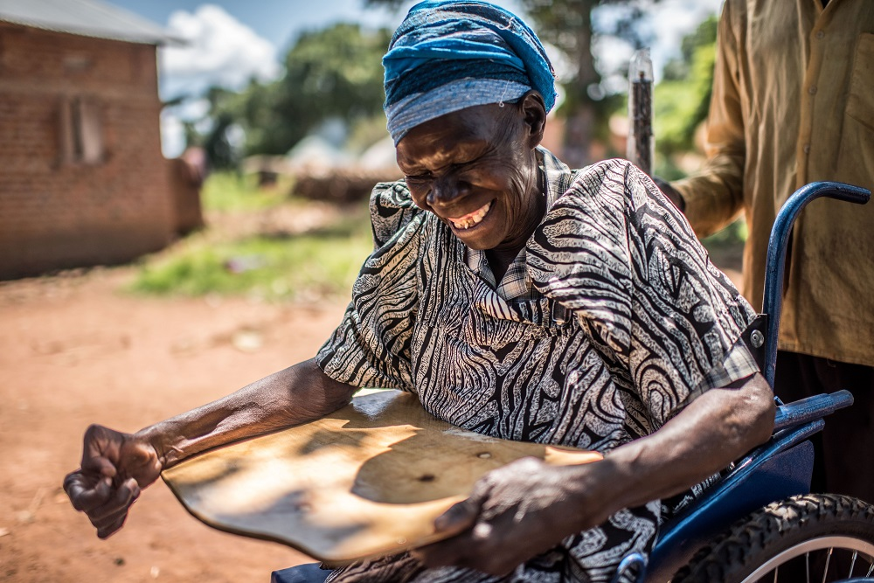
© CBM / Trenchard
- Scale up efforts to promote healthy and active ageing, maintain and improve quality of life of older people and to respond to the needs of the rapidly ageing population, especially the need for promotive, preventive, curative, rehabilitative and palliative care as well as specialized care and the sustainable provision of long-term care, taking into account national contexts and priorities. [A/RES/74/2, paragraph 30]
We therefore commit to scale up our efforts and to implement the following actions:
- To incorporate a disability- [, age-] and gender-sensitive and inclusive approach, including by closely consulting with and actively involving persons with disabilities and their representative organizations, in decision- making and designing programmes in order that they receive effective health services as part of universal health coverage; equal protection during complex humanitarian emergencies, and the occurrence of natural disasters and in their aftermath; and equal access to cross-sectoral public health interventions, such as provision of safe water, sanitation and hygiene services, to achieve the highest attainable standard of health. [WHA74.8]
- To identify and eliminate attitudinal, environmental and institutional obstacles and barriers that prevent persons with disabilities [of all ages] from accessing health, including sexual and reproductive healthcare services, as well as health-related information, skills and goods, including by making health facilities accessible, by training relevant professionals on the human rights, dignity, autonomy and needs of persons with disabilities, by making information available in accessible formats, and by providing appropriate measures for the exercise of legal capacity in health-related issues. [WHA74.8]
- To develop, implement and strengthen policies and programmes, as appropriate, to improve access to rehabilitation, as well as affordable and quality assistive technology within universal health and/or social services coverage, and to ensure their sustainability. [WHA74.8]
- To [remove upper age caps and] collect health-related data, disaggregated by disability, age and sex, education level and household income to inform relevant policies and programmes. [WHA74.8]
- Without discrimination on the basis of disability [, age, gender or any other ground], to provide health services and care of the same quality to persons with disabilities as to others, including on the basis of free and informed consent, respecting the human rights, dignity, autonomy, legal capacity and needs of persons with disabilities, including through training and the promulgation of ethical standards for public and private healthcare. [WHA74.8]
- To take measures to ensure comprehensive, accessible and affordable access to health systems and care for all persons with disabilities, while recognizing the unique vulnerabilities of those who may be living in care and congregated living settings in times of public health emergencies, and for special protection against infections in particular for at-risk groups, with protection to include facilitating the education of health and care workers in the area of infection prevention and control to protect all persons with disabilities, whether living in the community or in care and congregated living settings. [WHA74.8]
- To [put in place], according to their specific contexts, comprehensive, proportionate, time-bound, age- and disability-sensitive and gender-responsive measures against [epidemics, pandemics and other public health emergencies] across government sectors, ensuring respect for human rights and fundamental freedoms and paying particular attention to the needs of people in vulnerable situations, promoting social cohesion, taking the necessary measures to ensure social protection and protection from financial hardship, and preventing insecurity, violence, discrimination, stigmatization and marginalization; [WHA73.1]
- To ensure the continued functioning of the health system in all relevant aspects in accordance with national context and priorities, necessary for an effective public health response to [epidemics, pandemics and other public health emergencies] and the uninterrupted and safe provision of population- and individual-level services, for, among other matters, communicable diseases, including through undisrupted vaccination programmes, and for neglected tropical diseases, noncommunicable diseases, mental health, mother and child health and sexual and reproductive health; and to promote improved nutrition for women and children, recognizing in this regard the importance of increased domestic financing and development assistance where needed in the context of achieving universal health coverage; [WHA73.1]
- To provide access to safe testing, treatment, and palliative care for [disease during epidemics, pandemics and other public health emergencies], paying particular attention to the protection of those with pre-existing health conditions, older people, [persons with disabilities] and other people at risk, in particular health professionals, health workers and other relevant frontline workers. [WHA73.1]

Annex II: Linking action to advance health equity for persons with disabilities with the UHC2030 action agenda
‘From commitment to action’ - action agenda from the UHC movement | Action needed to advance health equity for persons with disabilities and older people: IDDC recommendations
Action area 1: Champion political leadership for universal health coverage  - Provide strategic leadership at the highest political level to champion universal health coverage as a national political priority through a whole-of-government approach.  - Strengthen and finance a comprehensive essential health benefits package based on epidemiological needs and disease burden, prioritizing primary health care as a foundation of health systems for both universal health coverage and health security.  - Encourage and support subnational governments, communities, civil society and private sector leadership and mobilization for universal health coverage. | - Provide political leadership to promote health equity for persons with disabilities of all ages  Prioritize health equity for persons with disabilities and formalize commitments and governance mechanisms for disability inclusion through policies and legislation that protect the right to health, prohibit discrimination and demand reasonable adjustments for persons with disabilities.
Action area 2: Leave no one behind  - Ensure that all national health policy frameworks address the health needs of vulnerable and disadvantaged groups throughout their life course.  - Remove the barriers of various types of discrimination from all national and local health policy frameworks.  - Collect the best available knowledge and information to design the policy, and measure progress in universal health coverage in order to leave no one behind. | - Make health systems, services and facilities more inclusive to benefit everyone and leave no one behind  Invest in universal design, community-based, person-centered and whole-of-society approaches founded upon primary healthcare and essential public health functions, ensuring that health and care services are accessible to all and close to where people live.  - Ensure UHC service packages enable persons with disabilities of all ages to enjoy their right to available, accessible, acceptable and quality goods, facilities, services and information that meet their physical and mental health needs across the full continuum of care and throughout the life course.  This must ensure expanded coverage of sexual and reproductive health services, health information, nutrition services, communicable and non-communicable disease prevention and care, immunization, rehabilitation and assistive products, palliative and end of life care, and integrated long-term care and support within the community.
Action area 3: Adopt enabling laws and regulations  - Create enabling legislative frameworks that strengthen health systems.  - Implement policies, laws and regulations for a comprehensive essential health benefits package, financial protection, primary health care and integrated services to support universal health coverage and health security.  - Adopt policies, laws and regulations that strengthen ecosystems for health-care technology and innovation to accelerate progress towards universal health coverage. | - Promote a human rights-based approach to health and UHC  Ensure progress towards UHC upholds the right of persons with disabilities to available, accessible, acceptable and quality health related goods, facilities and services, their right to participation in health-related decision-making processes and to non-discrimination, to ensure their enjoyment of the right to health on an equal basis with others. Guarantee free and informed consent and bodily autonomy for persons with disabilities of all ages.  - Promote deinstitutionalization for persons with disabilities of all ages and increase investment in community-based health and care services and support systems, including mental health services  Promote recovery, participation, and rights-based support in the community.
Action area 4: Strengthen the health and care workforce to deliver quality health care  - Implement existing international agreements to recognize and resource the health and care workforce as the foundation of resilient health systems.  - Apply robust planning and financing to retain, expand, and protect the health and care workforce.  - Invest in innovative care delivery models to improve the quality of health and care and foster trust. | - Develop competencies for disability inclusion for the health workforce and provide training in disability inclusion for all health service providers  This should include both mandatory pre-service disability inclusion training integrated within teaching curricula of health training institutions, as well as in-person training as part of continuous professional development plans for health and social workers.
Action area 5: Invest more, invest better  - Increase and stabilize levels of public spending on health to make health systems more resilient and equitable.  - Increase financing for primary health care to strengthen health systems and scale up services.  - Invest more to strengthen financial protection. | - Ensure progressive universalism and inclusive health financing in advancing UHC to eliminate the additional financial barriers that persons with disabilities and older people face in realizing their right to health  This should include testing and scaling-up solutions to reduce out-of-pocket expenditure for those who cannot afford it, while expanding access to health insurance and other community support systems, ensuring that essential services and additional costs for persons with disabilities are also covered.
Action area 6: Move together towards universal health coverage  - Champion participatory, inclusive governance and coordinate a meaningful whole-of-society approach for universal health coverage and health security.  - Institutionalize mechanisms for inclusive health governance and adopt policy frameworks that enable and resource social participation.  - Promote trust and transparency by strengthening accountability in health governance. | - Advance inclusive health governance, with specific mechanisms that ensure the meaningful engagement of persons with disabilities of all ages, including women and girls with disabilities and older people, and their representative organizations at all levels in health and care policy planning, implementation, monitoring and evaluation  Ensure disability-inclusive policy development, service design and feedback mechanisms for quality of health and care services and consider the specific requirements of persons with disabilities in systems to monitor care pathways.
Action area 7: Guarantee gender equality in health  - Eliminate gender inequality and discrimination in the design and delivery of health policy and services.  - Guarantee gender equality in health systems and decision-making at all levels, close the gender pay gap, and value and appropriately remunerate unpaid and underpaid health and care workers, including community health workers.  - Collect the best available knowledge and information on gender priorities and challenges to improve policy and programme design | - Prioritize access, inclusion and rights of persons with disabilities of all ages who are at higher risk of intersecting forms of discrimination and disadvantage or who are most exposed to negative social determinants of health  Ensure specific action to identify, include and fulfil the right to health for women and girls, children and older persons with disabilities, those living in poverty, and those who are displaced or in remote or insecure contexts.  - Remove upper age caps and collect, analyse, report and use sex-, age- and disability-disaggregated data on people of all ages to inform equity-based service design and delivery and decision-making in health to ensure progress towards universal population, service and financial coverage.  This should be based on reaching those with the greatest need who are the furthest behind first and linked to clear accountability measures.
Action area 8: Connect universal health coverage and health security  - Transform health systems and foster resilience through integrated approaches that connect universal health coverage to health security in order to ensure capacity to prepare for, prevent, detect and respond to disease outbreaks and other health emergencies.  - Build community trust in science, vaccines and public health institutions.  - Protect people against interruptions in essential health services during emergencies. | Prioritize equity, inclusion, meaningful participation and protection of persons with disabilities and older people and their right to the highest attainable standard of health in health emergency and disaster preparedness, response and recovery plans  This must include the prohibition of discrimination in the provision of healthcare, services or assistance on the basis of disability or age, ensuring continuing access to essential health products, services and facilities, and the continuation of support in the community.

About the International Disability and Development Consortium (IDDC)
The International Disability and Development Consortium (IDDC) is a grouping of civil society organizations coming together around a common objective: promoting inclusive international development and humanitarian action with a special focus on the full and effective enjoyment of human rights by all persons with disabilities.
A broad consortium, our membership includes organizations of persons with disabilities, non-governmental development organizations, national networks and international member-based networks.
For more info: inclusivehealth@iddcconsortium.net
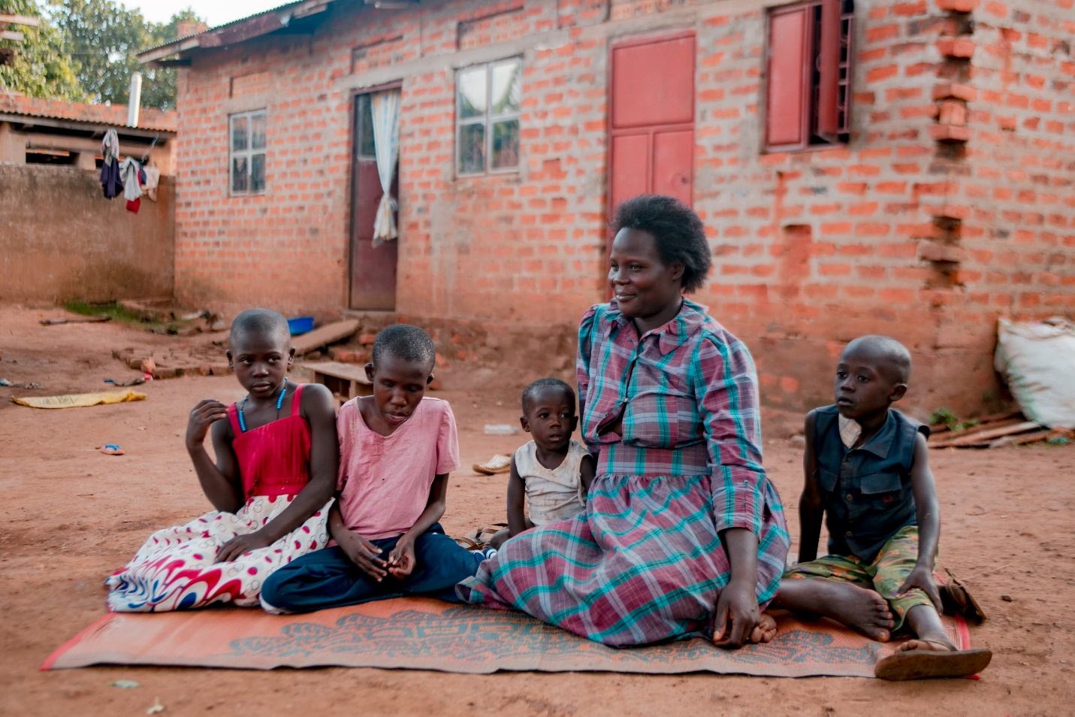
© Sightsavers / Martin Kharumwa

WHO, 2022. Global report on health equity for persons with disabilities, p.25 & UNICEF, 2021. Seen, counted, included: using data to shed light on the well-being of children with disabilities
The Missing Billion Initiative, 2022. Reimagining Health Systems That Expect, Accept and Connect 1 Billion People with Disabilities.
WHO, 2022. Global report on health equity for persons with disabilities, p.61.
OHCHR, 2020. Policy Guidelines for Inclusive Sustainable Development Goals: Good Health and Well-Being.
WHO, 2015. WHO global disability action plan 2014-2021. Better health for all people with disability
OHCHR, op. cit., p.8.
OHCHR, op cit., p.9.
The Missing Billion Initiative, op cit., p.8.
WHO, op cit., p.35, citing: S. Kamalakannan et al., 2021. ‘Health risks and consequences of a COVID-19 infection for people with disabilities: scoping review and descriptive thematic analysis’ & E. J. Williamson et al. ‘Risks of COVID-19 hospital admission and death for people with learning disability: population-based cohort study using the OpenSAFELY platform’
ICESCR, Article 12.
UN Convention on the Rights of Persons with Disabilities, Article 25.
Additional or alternative language suggested by IDDC has been inserted in square brackets.
Resolution adopted by the World Health Assembly: WHA71.8, accessed on 2nd March 2023 at: https://apps.who.int/gb/ebwha/pdf_files/WHA71/A71_R8-en.pdf?ua=1
Resolution adopted by the World Health Assembly: WHA72.3, accessed on 2nd March 2023 at: https://apps.who.int/gb/ebwha/pdf_files/WHA72/A72_R3-en.pdf
Resolution adopted by the World Health Assembly: WHA 74.8, accessed on 2nd March 2023 at: https://apps.who.int/gb/ebwha/pdf_files/WHA74/A74_R8-en.pdf
World Health Organization (2022) Global report on health equity for persons with disabilities; accessed on 2nd March 2023 at: https://www.who.int/publications/i/item/9789240063624
Resolution adopted by the World Health Assembly: WHA73.1, accessed on 2nd March 2023 at: https://apps.who.int/gb/ebwha/pdf_files/WHA73/A73_R1-en.pdf
Resolution adopted by the UN General Assembly: A/RES/75/131, accessed on 2nd March 2023 at: https://digitallibrary.un.org/record/3895802?ln=en
UHC2030, Action Agenda from the UHC Movement - UHC2030, March 2023.

