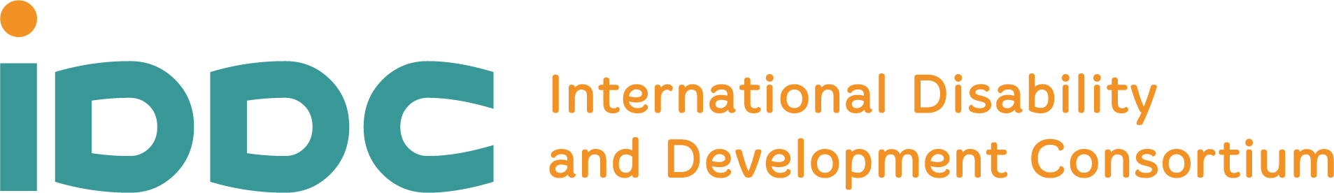

Our joint reaction to the High Level Meeting and the Political Declaration on Universal Health Coverage
A new Political Declaration on Universal Health Coverage that marks some steps forward, but demonstrates the weaknesses of global decision-making in delivering on health equity

Progress towards Universal Health Coverage (UHC) has stagnated and is backsliding. 4.5 billion people were not covered by essential health services in 2021. Two billion people had financial hardship in 2019 because they had to spend out of pocket on health (WHO, 2023). Persistent health inequities mean that persons with disabilities face, on average, much poorer health and functioning than the general population. Persons with disabilities have 2.4-fold higher mortality rates than those without disabilities and they are missing 10 to 20 years of life expectancy (WHO, 2022).
As a group non-governmental organisations and organisations of persons with disabilities that are members of the International Disability and Development Consortium (IDDC), we have joined forces to advocate for concerted action toward UHC. We have called to tackle inequalities across the continuum of care, with increased investments in inclusive health systems that are people-centred, community-based, and founded upon primary health care and whole-of-society approaches.
We welcome that a new Political Declaration was finally adopted at the High Level Meeting on September 21st, despite the bumpy path of negotiations ahead of the High Level Meeting.
This new Political Declaration on UHC marks some important steps forward in comparison with the previous 2019 Political Declaration, which we welcome, namely:
- Stronger language on health inequities experienced by persons with disabilities, as well as on the empowerment, participation and inclusion of women, children, youth, older people, and persons with disabilities. A specific call to ensure availability of and access to health services for all persons with disabilities, to enable their full participation in society and achievement of their life, in line with the Convention on the Rights of Persons with Disabilities.
- Commitment to advancing comprehensive approaches and integrated service delivery, with specific reference to the situation of persons with psychosocial disabilities.
- Emphasis on primary health care, to bring health services closer to where people live and make them more affordable.
- Stronger language on scaling up action to meet the growing needs of the rapidly ageing population, including noting the United Nations Decade of Healthy Ageing.
- Stronger language on rehabilitation, including via recognition of the increasing and largely unmet needs, in line with the Resolution adopted at the World Health Assembly earlier this year.
- Explicit recognition of assistive technology as part of health technologies, and of the challenges to access them.
- Stronger language on the need for long-term care and support, including home and community care services.
However, we are concerned that, while Member States jointly expressed deep worries regarding the lack of progress and the increasing inequity, the commitments in the Declaration are not sufficiently “action-oriented” to effectively tackle inequities and expand access for all, and it will be difficult to track progress in the implementation phase. While the Political Declaration anchors key principles to realize the right to health for all, concrete actions must now be taken by governments, donors, and other stakeholders, in order to translate these principles into reality.
We are also deeply concerned that consensus on such a pivotal topic was not reached on multiple occasions during the negotiations due to contentious issues that are geopolitical in nature, the current financial and economic crises, and diverging views over sexual and reproductive health and rights. As a result, language on burning and controversial issues was watered down, and in too many areas the 2023 Declaration simply reiterates the agreed text from 2019.
Furthermore, the adopted Declaration demonstrates that health systems continue being geared solely around the reduction of mortality and morbidity, lacking a comprehensive approach to health and well-being. Thus, it is unfortunate that the notion of “functioning” (the WHO-recognised health indicator, alongside mortality and morbidity) is absent in the text.
It is also deeply regrettable that the mechanisms for participation of civil society in the multistakeholder hearing and in the High Level Meeting were neither effective, nor inclusive. Voices from the Global South and of marginalized groups, including persons with disabilities, were underrepresented, due to the last-minute approval of registrations (not allowing sufficient time for visa requests), the in-person format (with high costs for travels and stay), a lack of clarity on the modalities to present statements, and the limited consultations at country and global levels. These non-inclusive modalities were not in line with the UN Disability Inclusion Strategy. In a global context of shrinking space for civil society, we expect that UN processes, such as UHC, are exemplary and genuinely inclusive to facilitate the role that civil society should play in delivering well-informed policy-making.
We should learn from the shortcomings of this process and build on the renewed commitments that it frames. Universal health coverage is essential for realising human rights, sustainable development, social justice and inclusion. It is clearly time to act, beyond political divisions and with the meaningful participation of individuals and groups who are still left behind.

Please also see our requests and statements for inclusive UHC here:
More than 70 organisations call for world leaders to deliver health equity for persons with disabilities and older people in progress towards UHC – IDDC (iddcconsortium.net)

